ORDINANCE NUMBER ________

AN ORDINANCE AMENDING THE FORT WORTH BUILDING CODE, BY ADOPTING THE 2015 INTERNATIONAL BUILDING CODE, WITH LOCAL AMENDMENTS; AMENDING SECTIONS 7-46, 7-47, 7-48, AND 7-49 OF THE CODE OF THE CITY OF FORT WORTH (1986); REGULATING THE ERECTION, CONSTRUCTION, ENLARGEMENT, ALTERATION, REPAIR, MOVING, REMOVAL, DEMOLITION, CONVERSION, OCCUPANCY, EQUIPMENT, DESIGN, QUALITY OF MATERIALS, USE , HEIGHT, AREA, REHABILITATION AND MAINTENANCE OF BUILDINGS AND STRUCTURES IN THE CITY OF FORT WORTH; DEFINING CERTAIN TERMS; PROVIDING FOR THE ISSUANCE OF PERMITS AND THE COLLECTION OF FEES THEREOF; PROVIDING FOR THE INSPECTION OF BUILDINGS; PROVIDING FOR A SEVERABILITY CLAUSE; PROVIDING FOR A SAVINGS CLAUSE; PROVIDING FOR A PENALTY CLAUSE; PROVIDING THAT THIS ORDINANCE SHALL BE CUMULATIVE; PROVIDING FOR PUBLICATION IN PAMPHLET FORM; PROVIDING FOR PUBLICATION IN THE OFFICIAL NEWSPAPER; AND PROVIDING AN EFFECTIVE DATE.

NOW, THEREFORE, BE IT ORDAINED BY THE CITY COUNCIL OF THE CITY OF FORT WORTH, TEXAS:

SECTION 1.

Section 7-46 of the Code of the City of Fort Worth (1986) is amended to read as follows:

Sec. 7-46. THE 2015 EDITION OF THE INTERNATIONAL BUILDING CODE ADOPTED.

(a) The Building Code of the City of Fort Worth is hereby revised and amended to conform, with certain exceptions as specified below, to the 2015 edition of the International Building Code of the International Code Council (ICC), and the same as amended is hereby adopted as the City's Building Code.

(b) The following provisions of the Appendix to the 2015 International Building Code is hereby specifically adopted as amended as part of the Building Code of the City of Fort Worth:

Appendix Chapter L, Sound Insulation Requirements for Noise Sensitive Uses near Airports (local amendment)

(c) The provisions of the Residential Code, as adopted elsewhere, shall be used for buildings and structures applicable to that code except as provided for in that code.

(d) One (1) copy of the 2015 edition of the International Building Code, marked Exhibit “A”, is incorporated herein by reference and shall be filed in the office of the City Secretary for permanent record and inspection.

(e) Any Errata corrections published by the International Code Council for the 2015 International Building Code, as they are discovered, are considered as part of this code.

SECTION 2.

That Section 7-47 of the Code of the City of Fort Worth (1986) is amended to read as follows:

Sec. 7-47. Amendments

The 2015 edition of the International Building Code is hereby amended to read as follows:

CHAPTER 1 – SCOPE AND ADMINISTRATION

*IBC Chapter 1; "SCOPE AND ADMINISTRATION” is hereby deleted and replaced with the Fort Worth Building Administrative Code;

CHAPTER 2 - DEFINITIONS

IBC SECTION 201
GENERAL

*IBC Section 201.3; changed to read as follows:

201.3 Terms defined in other codes. Where terms are not defined in this code and are defined in other codes, such terms shall have the meanings ascribed to them as in those codes. Where the terms occur in multiple codes and are defined differently, each definition shall apply as appropriate in the context being used.

IBC SECTION 202
DEFINITIONS

*IBC Section 202; definitions are changed and new definitions are added to read as follows:

ASSISTED LIVING FACILITIES. A building or part thereof housing persons, on a 24-hour basis, who because of age, mental disability or other reasons, live in a supervised residential environment which provides personal care services. The occupants are capable of responding to an emergency situation without physical assistance from staff.

ATRIUM. An opening connecting two three or more stories other than enclosed stairways, elevators, hoistways, escalators, plumbing, electrical, air-conditioning or other equipment, which is closed at the top and not defined as a mall. Stories, as used in this definition, do not include balconies within assembly groups or mezzanines that comply with Section 505.

ATTIC. The space between the ceiling beams of the top story and the roof rafters. The installation of decking, other than the minimum decking required for equipment access and maintenance, shall be considered another story.

BARRIER. A permanent fence, wall, building wall or combination thereof that completely surrounds the swimming pool and obstructs access to a swimming pool. The term “permanent” shall mean not being able to be removed, lifted, or relocated without the use of a tool.

BUILDING CODE. Building Code shall mean the International Building Code as adopted by this jurisdiction.

CHANGE OF OCCUPANCY. A change in the purpose or level of activity within a building that involves a change in application of the requirements of this code. The definition shall also apply to usage of the surrounding site and access to and from the building, structure or site, as necessary to achieve the purpose of this code, and to obtain compliance with other codes and ordinances of this jurisdiction.

CODE OFFICIAL. Where ever the term code official is used in this code it shall mean building official.

COMMON PATH OF EGRESS TRAVEL. That portion of exit access travel distance measured from the most remote point within a story to that point were the occupants have separate access to two exits or exit access doorways. Common paths of egress shall be measured in the same manner as the travel distance.

CORRIDOR. An enclosed exit access component that defines and provides a path of egress travel to an exit. The term also includes Open-Ended Corridor and Breezeways.

ELECTRICAL CODE. Electrical Code shall mean the National Electrical Code as adopted by this jurisdiction. For the purpose of this code, all references to NFPA 70 and the ICC Electrical Code shall be assumed to mean the Electrical Code as defined herein.

ENERGY CODE. Energy Code shall mean the International Energy Code as adopted by this jurisdiction.

FIRE PREVENTION CODE (FIRE CODE). Fire Prevention Code, or Fire Code, shall mean the International Fire Code as adopted by this jurisdiction.

FORT WORTH BUILDING ADMINISTRATIVE CODE. The Fort Worth Administrative code containing the administrative, organizational, and enforcement rules and regulations for the Fort Worth Building, Residential, Plumbing, Fuel Gas, Mechanical, Electrical, Sign and Existing Building codes.

FUEL GAS CODE. Fuel Gas code shall mean the International Fuel Gas Code as adopted by this jurisdiction and shall be considered as part of the Plumbing Code.

MECHANICAL CODE. Mechanical Code shall mean the International Mechanical Code as adopted by this jurisdiction.

OCCUPIABLE SPACE. A room or enclosed space designed for human occupancy in which individuals congregate for amusement, educational or similar purposes or in which occupants are engaged at labor, and which is equipped with means of egress and light and ventilation facilities meeting the requirements of this code. Any space that could be assumed to be occupiable shall not be exempt to the requirements of this code by designing the space without means of egress, light or ventilation.

OCCUPIED ROOF. Uncovered roof or roof deck, designed to be occupied for uses other than mechanical equipment or building services, including but not limited to swimming pools, dining, amusement, gardens and parking. Such areas shall be considered as another story in which an occupancy exists.

PLUMBING CODE. Plumbing Code shall mean the International Plumbing Code and the International Fuel Gas Code as adopted by this jurisdiction. The term "Plumbing Code" applies to both codes as one combined code.

PLUMBING SYSTEM.
For the purpose of using the International Plumbing Code, as adopted, shall mean:

Includes the water supply and distribution pipes; plumbing fixtures and traps; water-treating or water-using equipment; soil, waste and vent pipes; and sanitary and storm sewers and building drains; in addition to their respective connections, devices and appurtenances within a structure or premises.

PUBLIC WAY. A street, alley or other parcel of land open to the outside air leading to a street, that has been deeded, dedicated or otherwise permanently appropriated to the public for public use and which has a clear width and height of not less than 10 feet (3048 mm).

An active railway line, that is owned and operated by a railway corporation, in which the land is unplatted, extending through the jurisdiction without interruption by property lines, shall be considered as a Public Way. Railway easements, utility easements or any other type of easement on a neighboring property shall not be considered as Public Way.

REPAIR GARAGE. A building, structure or portion thereof used for servicing or repairing motor vehicles. This occupancy shall not include motor fuel-dispensing facilities, but shall include any auto repair bays. This occupancy shall also include facilities involved in minor repair, modification and servicing of motor vehicles for items such as lube changes, inspections, windshield repair or replacement, shocks, minor part replacement and other such minor repair.

RESIDENTIAL CODE. Residential Code shall mean the International Residential Code as adopted by this jurisdiction.

SPECIAL INSPECTOR. A qualified person employed or retained by an approved agency who shall prove to the satisfaction of the registered design professional in responsible charge and approved by the Building Official as having the competence necessary to inspect a particular type of construction requiring special inspection.

STAIRWAY, EXTERIOR. A stairway that is open on at least one side, except for required structural columns, beams, handrails and guards in accordance with Section 1027.3. The adjoining open areas shall be in direct contact with either yards, courts or public ways. The other sides of the exterior stairway need not be open.

Any stairway at the end of an open ended corridor that is pulled into the building shall be considered an exterior stair if in compliance with both of the following provisions:

- The bottom riser is no more than one foot (1’) inside the exterior wall, and
- No riser is located more than twenty feet (20’) inside the exterior wall.

STORY, FIRST. The lowest story qualifying as a Story Above Grade Plane shall be considered as the first story.

SWIMMING POOL, INDOOR. A swimming pool which is totally contained within a structure and surrounded on all four sides by walls of said structure.

SWIMMING POOL, OUTDOOR. Any swimming pool which is not an indoor pool.

TECHNICAL CODES. The Fort Worth Building, Residential, Plumbing, Fuel Gas, Mechanical, Electrical, Sign and Existing Building codes which regulate the construction, alteration, relocation, enlargement, replacement, repair, equipment, use and occupancy, location, maintenance, removal and demolition of every building or structure or any appurtenances connected or attached to such buildings or structures.

TOWNHOUSE. A single-family dwelling unit constructed in a group of three or more attached units individually separated by property lines in which each unit extends from the foundation to roof and with a yard or public way on at least two sides. When not divided with a property line, such units shall be considered as Townhouse Apartments and shall comply with the provisions for apartments, except where separate provisions are provided.

TOWNHOUSE APARTMENT. A single-family dwelling unit constructed in a group of three or more attached units in which each unit extends from the foundation to roof and with open space on at least two sides.

TREATED WOOD. Wood and wood-based materials that use vacuum-pressure impregnation processes to enhance fire retardant or preservative properties.

Fire-retardant-treated wood. Pressure-treated lumber and plywood in accordance with Sections 2303.2, 2303.2.1, 2303.2.2, 2303.2.3 and 2303.2.4 that exhibit reduced surface-burning characteristics and resist propagation of fire.

Preservative-treated wood. Pressure-treated wood products that exhibit reduced susceptibility to damage by fungi, insects or marine borers.

ZONING CODE. Zoning Code shall mean the Comprehensive Zoning Ordinance as adopted.

CHAPTER 3 – USE AND OCCUPANCY CLASSIFICATION

IBC SECTION 302
CLASSIFICATION

*IBC Section 302.1; add a sentence at the end of the first paragraph to read as follows:

For application of this code to uses under the Residential Code, they shall be considered to be Group R-3 residential uses with Group U accessory uses, unless a more appropriate occupancy group is assigned by the building official.

IBC SECTION 303
ASSEMBLY GROUP A

*IBC Sections 303.1.3; add a sentence to read as follows:

303.1.3 Associated with Group E occupancies. A room or space used for assembly purposes that is associated with a Group E occupancy is not considered a separate occupancy. Except when applying the assembly requirements of Chapter 10 and 11.

*IBC Section 303.4, Group A-3; add a new use to read as follows:

Dining halls associated with Group E occupancies.

IBC SECTION 304
BUSINESS GROUP B

*IBC Section 304.1; change and add uses to read as follows:

Educational occupancies above the 12th grade with less than 50 occupants per room

Fire stations

Police stations (includes an area to confine or restrain up to five individuals)

Training and skill development not within a school or academic program with an occupant load less than 50.

IBC SECTION 307
HIGH-HAZARD GROUP H

*IBC Section 307.4; add a new use as follows:

Aircraft paint hangars, when required by Section 412.6.1.

IBC SECTION 308
INSTITUTIONAL GROUP I

*IBC Section 308.2, add new defined term as follows:
Assisted Living Facility

*IBC Section 308.3, add new uses under I-1 as follows:

Orphanage for children over 2 ½ years of age
Foster home with more than 16 care recipients, exclusive of the primary family

*IBC Section 308.4; add two new uses under I-2 as follows:

Orphanage for children under 2 ½ years of age
Foster home for more than five children 2 ½ years of age or less, exclusive of the primary family
All I-1 and Group R uses, not regulated by the IRC, in which the occupants are not capable of responding to an emergency situation without physical assistance from staff.

IBC SECTION 310
RESIDENTIAL GROUP R

*IBC Section 310.2, add new defined term as follows:
Assisted Living Facility

*IBC Section 310.3; add new use to read as follows:

Bed and Breakfast Inn as defined in the Zoning Code

*IBC Section 310.4; add new use to read as follows:

Townhouse Apartments

*IBC Section 310.4.1; added to read as follows:

310.4.1. Townhouse apartments. Townhouse apartments shall comply with all provisions applicable to Group R-2 apartments.

When townhouse apartments are constructed in accordance with the provisions of the Residential Code, as listed in Sections 310.4.1 and 310.4.2, such apartments are permitted reductions in code compliance as specified in Sections 310.4.1.3, 310.4.1.4 and 310.4.1.5.

310.4.1.1 Height. For the purpose of code reductions, townhouse apartments shall not exceed 3 stories in height.

Exceptions:
1. Such structures are permitted to have a private, individual fourth level roof deck in compliance with the following:
- Except for required guards, and the minimum required penthouse necessary to enclose the access stair, the deck shall be unenclosed and unroofed.
- The minimum required penthouse necessary to enclose the access stair shall not include any other occupiable space.
- The open deck shall not exceed 400 square feet.
- The guard shall be constructed of metal. The decking shall be constructed of water resistant construction, and the structural design plans of the building and deck shall be stamped by an engineer.

2. When each unit of the townhouse apartment building is provided with an automatic sprinkler system, the fourth level roof deck may be as provided in exception 1 and the following:
a. with an automatic sprinkler system in accordance with Section 903.3.1.1 or 903.3.1.2 with 903.3.1.2.1:
- the 400 square foot area may be covered but open on the sides; and,
- part of the 400 square feet area may be an enclosed storage room not to exceed 20 square feet.

b. with an automatic sprinkler system in accordance with 903.3.1.2 (without 903.3.1.2.1), 903.3.1.3 or Section P2904 of the Residential Code, the provisions of exception 2a above apply except that the canopy must be entirely non-combustible.

310.4.1.2 Separation. For the purpose of code reductions, townhouse apartments shall be separated as required by Section R302.2, R302.2.1, R302.2.2, R302.2.3 and R302.2.4 of the Residential Code.

310.4.1.3 Automatic sprinkler reduction. When in compliance with Section 310.3.1 and 310.3.2 and required to install an automatic sprinkler system in accordance with Section 903.2.8, individual systems per townhouse apartment may be installed in compliance with Section 903.3.1.3 or Section P2904 of the Residential Code.

310.4.1.4 Manual fire alarm systems. When in compliance with Sections 310.3.1 and 310.3.2, manual fire alarm systems in accordance with Section 907.2.9.1 are not required.

310.4.1.5 Means of egress. When in compliance with Sections 310.3.1 and 310.3.2, means of egress may be in compliance with Section R311 of the Residential Code.

*IBC Section 310.5; add a second paragraph and use to read as follows:

This use shall include not more than two dwelling units that are an attached part of another use, e.g. caretaker unit for self-storage facility, residence over a commercial business, etc. Unless in separate detached one- or two-family structures, structures with three or more dwelling units on a single property shall constitute a Group R-2 apartment or Townhouse Apartment regardless of whether divided by fire walls or party walls.

Bed and Breakfast Home as defined in the Zoning Code

*IBC Section 310.6; add new use to read as follows:

Community Home as defined in the Zoning Code.
Group Home I as defined in the Zoning Code

CHAPTER 4 – SPECIAL DETAILED REQUIREMENTS BASED ON USE AND OCCUPANCY

IBC SECTION 403
HIGH-RISE BUILDINGS

*IBC Section 403.1, exception #3; changed to read as follows:

3. The open air portion of a bBuildings with an occupancy in Group A-5 in accordance with Section 303.6.

*IBC Section 403.3, exception #2; change to read as follows:.
2. As identified in Section 903.3.1.1.1 when approved by the fire code official. {Delete rest of exception.}

*IBC Section 403.3.2; change to read as follows:

[F] 403.3.2 Water supply to required fire pumps. In buildings that are more than 420 120 feet (36.5 m) in building height, required fire pumps shall be supplied by connections to no fewer than two water mains located in different streets. Separate supply piping shall be provided between each connection to the water main and the pumps. Each connection and the supply piping between the connection and the pumps shall be sized to supply the flow and pressure required for the pumps to operate.

Exception: {No change to exception.}

*IBC Section 403.4.7; delete

IBC SECTION 406
MOTOR-VEHICLE-RELATED OCCUPANCIES

*IBC Section 406.8.1 changed to read as follows:

406.8.1 General. Repair garages shall be constructed in accordance with the International Fire Code and Sections 406.8.1 through 406.8.6. This occupancy shall not include motor fuel-dispensing facilities, as regulated in Section 406.7, but shall include any auto repair bays.

This occupancy shall also include garages involved in minor repair, modification and servicing of motor vehicles for items such as lube changes, inspections, windshield repair or replacement, shocks, minor part replacement and other such minor repair.

IBC SECTION 408
GROUP I-3

*IBC Section 408.3.9; added to read as follows:

408.3.9 Corridors. Open-barred cells forming corridor walls shall not be required to be fire-resistive. When cell walls are also the corridor walls, cell doors are permitted to have openings necessary to observe, communicate, feed or otherwise interact with the inmate.

IBC SECTION 411
SPECIAL AMUSEMENT BUILDINGS

*IBC Section 411.7.1; changed to read as follows:

411.7.1 Photo luminescent exit signs. Photo luminescent exit signs shall not be installed. Where photo luminescent exit signs are installed, activating light source and viewing distance shall be in accordance with the listing and markings of the signs.

IBC SECTION 412

*IBC Section 412.4.6 and 412.4.6.1; changed to read as follows:
412.4.6 [F] Fire Suppression. { Delete Exception and replace as follows:}

Exception: Group II hangars used for storage of aircraft and only routine maintenance shall have a fire suppression system, but the system shall be exempt from foam requirements. Hazardous operations equipment (torch cutting, welding and spray equipment) is prohibited in Group II hangars without a foam fire suppression system.

412.4.6.1 [F] Hazardous operations. Delete and replace as follows:

412.4.6.1Hazardous operations. Any Group II, III or IV aircraft hangar according to Table 914.8.3 that contains hazardous operations equipment or performs hazardous operations including, but not limited to, the following shall be provided with a foam fire suppression system in accordance with NFPA 409 as applicable:

1. Doping.
2. Hot work including, but not limited to, welding, torch cutting and torch soldering.
3. Fuel transfer as prohibited in Section 1104.1.1 of the Fire Code.
4. Fuel tank repair or maintenance not including defueled tanks in accordance with NFPA 409, inerted tanks or tanks that have never been fueled.
5. Spray finishing operations.

Exception: Group I, II, and III hangars as defined in NFPA 409 for storing or servicing aircraft that strictly contain only unfueled aircraft at all times with appropriate de-fueling operations outside of the hangar shall be exempt from foam suppression requirements only.

914.8.3.1.1 Prohibited equipment. Torch cutting, welding or spray equipment is prohibited in new and existing Group III hangars in any of the following situations:
- Group III hangars having fueled aircraft, but not provided with a foam fire suppression system, or
- Unsprinklered Group III hangars.

IBC SECTION 423
Storm Shelters

*IBC Section 423.3; changed to read as follows:

423.3 Critical emergency operations. In areas where the shelter design wind speed for tornados, in accordance with Figure 304.2(1) of ICC 500 is 250 MPH, new buildings for 911 call stations, emergency operation centers and fire, rescue, ambulance, and police stations shall be a storm shelter construction in accordance with ICC 500.

Exception: {unchanged}

*IBC Section 423.4; changed to read as follows:

423.4 Group E occupancies. In areas where the shelter design wind speed for tornados, in accordance with Figure 304.2(1) of ICC 500 is 250 MPH, all new buildings for Group E occupancies with an aggregate occupant load … {remainder unchanged}.

IBC SECTION 424
Children’s Play Structures

*IBC Section 424.5; delete.

CHAPTER 5 – GENERAL BUILDING HEIGHTS AND AREAS

IBC SECTION 503
GENERAL BUILDING HEIGHT AND AREA LIMITATIONS

*IBC Section 503.1; add a second paragraph to read as follows:

An occupancy, including those on Occupied Roofs, shall not be located above the story or height set forth in Tables 504.3 and 504.4 except as modified hereafter. For non-separated mixed uses, in accordance with Section 508.3, no occupancy shall be located above the story or height of the most restrictive non-separated occupancy.

*IBC Section 503.1.4; added to read as follows:

503.1.4 Fire protection systems. Any existing fire extinguishing system or fire alarm system, whether installed voluntarily or as a requirement of any previous code, shall be maintained and kept operational as required in the Fire Code. Such systems shall not be removed unless permitted to be removed or reduced by this code and the Fire Code.

IBC SECTION 506
BUILDING AREA

*IBC Section 506.3.1; add a sentence to read as follows:

In order to be considered having access from the street or approved fire lane, if not in direct contact with a street or fire lane, a minimum 10 foot wide pathway meeting fire department access from the street or approved fire lane must be provided.

IBC SECTION 509
INCIDENTAL USES

*IBC Section 509.4.1; add two sentences to read as follows:
…Section 707 or a horizontal assembly constructed in accordance with 711, or both so as to completely separate adjacent occupancies.

*IBC Section 509.4.2; add two sentences to read as follows:

In order to qualify with this reduction, at least one sprinkler head must be installed in the incidental use area. Areas that are exempt to sprinkler head installation under a sprinkler standard will not qualify for the reduction permitted herein unless at least one sprinkler head is installed in the incidental use area.

CHAPTER 6 – TYPES OF CONSTRUCTION

IBC SECTION 602
CONSTRUCTION CLASSIFICATION

*IBC Table 602; amend footnote “d” to read as follows:

- The fire-resistance rating of an exterior wall is determined based upon the fire separation distance of the exterior wall and the story in which the wall is located. When an upper floor projects closer to the property line than the floors below, and if Table 705.8 requires any percentage of protected openings for the exterior wall of that upper floor, then the underside of the projecting floor shall be a minimum of one-hour fire resistance rating.

IBC SECTION 603
COMBUSTIBLE MATERIAL IN TYPE I AND II CONSTRUCTION

*Section 603.1; change item 14 to read as follows:

- Fire-retardant-treated wood used as blocking such as for handrails, millwork, cabinets and window and door frames.

CHAPTER 7 – FIRE AND SMOKE PROTECTION FEATURES

IBC SECTION 706
FIRE WALLS

*IBC Section 706.2; add exceptions to read as follows:

Exceptions:
1. When necessary to install a two- or three-hour fire wall of not more than two stories in height in an existing building, a fire-resistant wall of the same rating, as specified in Table 706.4, that encapsulates a structural column line shall be accepted.
2. When necessary to install a two- or three-hour fire wall of not more than two stories in height between an existing building and a new addition, a double fire wall, one on the existing building and one on the new building, both of the required fire rating, as specified in Table 706.4, shall be acceptable. Fire doors may be installed in one of the walls with a water curtain installed at the opening of the other wall.

IBC SECTION 712
VERTICAL OPENINGS

*IBC Section 712.1.9; change item 4 to read as follows:

712.1.9 Two-Story openings. In other than Groups I-2 and I-3, a vertical opening that is not used as one of the applications listed in this section shall be permitted if the opening complies with all of the items below:

1. Does not connect more than two adjacent stories.
2. Does not penetrate a horizontal assembly that separates fire area or smoke barriers that separate smoke compartments.
3. Is not concealed within the construction of a wall or a floor/ceiling assembly.
4. Is not open to a corridor in Groups H and I and R occupancies.
5. Is not open to a corridor on nonsprinklered floors in any occupancy.
6. Is separated from floor openings and air transfer openings serving other floors by construction conforming to required shaft enclosures.
7. Is limited to the same smoke compartment.

IBC SECTION 717
DUCTS AND AIR TRANSFER OPENINGS

*IBC Section 717.5.3.1; added to read as follows:

717.5.3.1 Installation requirements. Exhaust systems for Group B and R kitchen, clothes dryer, bathroom and toilet room exhausts shall comply with the following:

- Kitchen systems, clothes dryer systems, and bathroom and toilet room systems may share the same shaft but not the same duct. When multiple ducts are in the same shaft, each system shall have its own fan providing continuous upward flow.
- Dryer ducts shall have a cleanout located near the shaft penetration to permit cleaning of the 22” subduct. The subduct shall be considered in the calculation of allowable duct length reduction.
- Kitchen ducts shall be provided with some method for preventing grease buildup and cleaning of the duct.
- A secondary power source is required for the fan under both Section 909.11 and Mechanical Code Section 504.8.
- See also Mechanical Code Section 504.8.

CHAPTER 9 – FIRE PROTECTION SYSTEMS

SECTION 901
GENERAL

Section 901.1 – Add sentence to read as follows:

Fire protection equipment required by this code shall be listed or approved for the intended use by a nationally recognized testing laboratory, unless otherwise approved by the fire code official.

Section 901.2 – Add sentence to read as follows:

Submittal of plans, specifications, and appropriate calculations for fire protection systems and appurtenances shall be made to the fire department by a fire protection systems contractor who is appropriately licensed per the Texas Administrative Code requirements and registered with the Fort Worth Fire Department.

IBC SECTION 903
AUTOMATIC SPRINKLER SYSTEMS

*IBC Section 903.1.1; change to read as follows:

[F] 903.1.1 Alternative protection. Alternative automatic fire-extinguishing systems complying with Section 904 shall be permitted in lieu of addition to required automatic sprinkler protection where recognized by the applicable standard or as approved by the fire code official.

*IBC Section 903.1.1.3 – Add to read as follows:

903.1.1.3 Exterior projections/canopies. All exterior projections/canopies exceeding 4 ft. in width/depth from the building, whether attached or not, shall be sprinklered.

Exception:
- Canopies meeting NFPA 13 requirements for noncombustible or limited combustible construction or fire retardant treated wood for pedestrian use only.
- Canopies that are detached/separated from the sprinklered building as required by the Building Code to be considered a separate building and meeting the allowable area requirements of the Building Code as a non-sprinklered building.

*IBC Section 903.1.2; added to read as follows:

[F] 903.1.2 Residential systems. Reductions to provisions of this code, commonly referred to as “building code tradeoffs,” shall not apply to systems installed in accordance with NFPA 13R or 13D unless the pertinent section contains a direct reference to Sections 903.3.1.2 or 903.3.1.3. When “tradeoffs” are used in the building design that are not authorized for NFPA 13R or 13D systems, the sprinkler installation shall be in accordance with NFPA 13.

For clarification of the appropriate system, the sprinkler designer/installer should consult the building designer and the appropriate plan reviewer or third party plan reviewer.

Residential sprinkler systems installed in accordance with NFPA 13R shall include attic sprinkler protection in buildings of three or more stories.

*IBC Section 903.2; changed to read as follows:

[F] 903.2 Where required. Approved automatic sprinkler systems in new buildings and structures shall be provided in the locations described in Sections 903.2.1 through 903.2.12. In order to prohibit elevator shunt trip, automatic sprinklers shall not be installed in elevator machine rooms, elevator machine spaces, and elevator hoistways (except for hydraulic elevator pits where such does not initiate the shunt trip requirement in the State Elevator Code), or as approved by the fire code official. Storage shall not be allowed within the elevator machine room. Signage shall be provided at the entry doors to the elevator machine room indicating “ELEVATOR MACHINERY – NO STORAGE ALLOWED.” Such signage shall comply with Section 509 of the Fire Code.

Exception: {deleted}

*IBC Section 903.2.1.2; add an exception to read as follows:

Exception: Where the building is existing, single story, and multi-tenant with independent egress per tenant space, only the single tenant fire area (separated by fire barriers) shall require sprinkler protection.

*IBC Section 903.2.1.3; add an exception to read as follows:

Exception: Where the building is existing, single story, and multi-tenant with independent egress per tenant space, only the single tenant fire area (separated by fire barriers) shall require sprinkler protection.

*IBC Section 903.2.1.6 – Delete the exception as follows:

Exception: Open parking garages of Type I or Type II construction.

*IBC Section 903.2.4.1; add a sentence to read as follows:

For dust collection requirements, see Mechanical Code Section 510.2.1.1. and reference IFC Section 2803.2.2 .

*IBC Section 903.2.7; add an exception to read as follows:

Exception: Where the building is existing, single story, and multi-tenant with independent egress per tenant space, only the single tenant fire area (separated by fire barriers) shall require sprinkler protection.

*IBC Section 903.2.8 and 903.2.8.1; changed to read as follows:

[F] 903.2.8 Group R. An automatic sprinkler system installed in accordance with Section 903.3 shall be provided throughout all buildings with a Group R fire area, other than one- and two-family dwellings, and townhomes in compliance with the Residential Code.

[F] 903.2.8.1 Group R-1 and R-2. An automatic sprinkler system shall be provided throughout buildings with a Group R-1, or R-2 fire area, other than one- and two-family dwellings, and townhomes in compliance with the Residential Code.

Exceptions:
- Where no portion of the R-1 or R-2 fire area is located higher than the second story, nor in a basement, and such R-1or R-2 use complies with any of the following conditions:
  - For other than Group R-2 apartments, the occupant load is less than ten (10).
  - The building when used as Group R-2 apartments contains less than five (5) dwelling units.
- A residential sprinkler system installed in accordance with Section 903.3.1.2 shall be permitted in buildings, or portions thereof, of Group R-1 and R-2 in accordance with the limitations of Section 903.1.2.

*IBC Section 903.2.8.4; Deleted.

[F] 903.2.8.2 Group R-4. An automatic sprinkler system shall be provided throughout all buildings with a Group R-4 fire area.

Exception: An automatic sprinkler system installed in accordance with Section 903.3.1.2 or Section 903.3.1.3 shall be allowed in Group R-4 facilities in accordance with the limitations of Section 903.1.2.

*IBC Section 903.2.9.3; added to read as follows:

[F] 903.2.9.3. Self-service storage facility. An automatic sprinkler system shall be installed throughout all self-service storage facilities The minimum sprinkler system design shall be based on an Ordinary Group II classification, in accordance with NFPA 13 requirements.

Exception: One story self-service storage facilities that have no interior corridors and are provided with a one-hour fire barrier wall installed between every storage compartment.

*IBC Section 903.2.11.3; exception #2 deleted and exception #1 changed to read as follows:

Exception:
- Open parking structures with no other occupancies above and in compliance with Section 406.5.
- {delete}

*IBC Section 903.2.11.7; added to read as follows:

[F] 903.2.11.7 Spray Booths and Rooms. New and existing spray booths and spraying rooms shall be protected by an approved automatic fire-extinguishing system.

*IBC Section 903.3.1.1.1; changed to read as follows:

[F] 903.3.1.1.1 Exempt locations. When approved by the fire code official, automatic sprinklers shall not be required in the following rooms or areas where such rooms or areas are protected with an approved automatic fire detection system in accordance with Section 907.2 that will respond to visible or invisible particles of combustion. Sprinklers shall not be omitted from any room merely because it is damp, of fire-resistance-rated construction or contains electrical equipment.

- A room where the application of water, or flame and water, constitutes a serious life or fire hazard.
- A room or space where sprinklers are considered undesirable because of the nature of the contents, when approved by the fire code official.
- Generator and transformer rooms, under the direct control of a public utility, separated from the remainder of the building by walls and floor/ceiling or roof/ceiling assemblies having a fire-resistance rating of not less than 2 hours.
- Rooms or areas that are of noncombustible construction with wholly noncombustible contents.
- Fire service access elevator machine rooms and machinery spaces. (Shunt trip prohibited.)
- Elevator hoistways (other than hydraulic pits) and elevator machine rooms enclosed by fire barriers as required by the International Building Code. Signage shall be provided at the entry doors to the elevator machine room indicating “ELEVATOR MACHINERY – NO STORAGE ALLOWED.” (Shunt trip prohibited.) Machine rooms, machinery spaces, control rooms and control spaces associated with occupant evacuation elevators designed in accordance with Section 3008 of the International Building Code.

*IBC Section 903.3.1.2; changed to read as follows:

903.3.1.2 NFPA 13R sprinkler systems. Automatic sprinkler systems in Group R occupancies up to and including four stories in height in buildings not exceeding 60 feet (18 288 mm) in height above grade plane shall be permitted to be installed throughout in accordance with NFPA 13R. However, when “building code tradeoffs” that are not authorized for NFPA 13R systems are used in the building design, the sprinkler installation shall be in accordance with NFPA 13. (See Section 903.1.2)

Residential sprinkler systems installed in accordance with NFPA 13R shall include attic sprinkler protection in buildings of three or more stories.

The number of stories of Group R occupancies constructed in accordance with Sections 510.2 and 510.4 of the International Building Code shall be measured from grade plane the horizontal assembly creating separate buildings.

*IBC Section 903.3.1.4, 903.3.1.4.1 and 903.3.1.4.2; added to read as follows:

[F] 903.3.1.4 Freeze protection. Freeze protection systems for automatic fire sprinkler systems shall be in accordance with the requirements of the applicable referenced NFPA standard and this section.

[F] 903.3.1.4.1Attics. Only dry-pipe, preaction, or listed antifreeze automatic fire sprinkler systems shall be allowed to protect attic spaces, unless otherwise approved by the fire code official .

Exception: Wet-pipe fire sprinkler systems shall be allowed to protect non-ventilated attic spaces where the attic space is a part of the building’s thermal, or heat, envelope, such that insulation is provided at the roof deck, rather than at the ceiling level.

[F] 903.3.1.4.2 Heat trace/insulation. Heat trace/insulation shall only be allowed where approved by the fire code official for small sections of large diameter water-filled pipe.

*IBC Section 903.3.1.5; added to read as follows:

[F] 903.3.1.5 Multiple or detached buildings. Multiple or detached buildings shall not be allowed to be supplied by a single fire sprinkler riser, unless specifically approved by the fire code official.

*IBC Section 903.3.5; add a second paragraph to read as follows:

Every fire protection system shall be designed with a 5 psi safety factor, in addition to water fluctuation adjustments required by Section 507.4 of the Fire Code.

*IBC Section 903.3.7.1; added to read as follows:

[F] 903.3.7.1 Locking FDC Caps. New FDC installations shall be equipped with locking fire department connection caps as approved by the fire code official. Existing FDC installations will require approved locking fire department connection caps to be installed when directed by the fire code official.

*IBC Section 903.4; add a second paragraph after the exceptions to read as follows:

Sprinkler and standpipe system water-flow detectors shall be provided for each floor tap to the sprinkler system and shall cause an alarm upon detection of water flow for more than forty-five (45) seconds. All control valves in the sprinkler and standpipe systems shall be electrically supervised.

*IBC Section 903.4; add exception #8 to read as follows:

8. Control valves associated with a backflow prevention device that is installed outside of a building. Such valves must be chained and locked in the open position even if located in a locked vault or enclosure.

*IBC Section 903.4.2; change to read as follows:

[F] 903.4.2 Alarms. An approved audible sprinkler waterflow alarm device, located on the exterior of the building in an approved location, shall be connected to each automatic sprinkler system Such sprinkler waterflow alarm devices shall be activated by water flow equivalent to the flow of a single sprinkler of the smallest orifice size installed in the system. Where a fire alarm system is installed, actuation of the automatic sprinkler system shall actuate the building fire alarm system.
The alarm device required on the exterior of the building shall be a weatherproof horn/strobe notification appliance with a minimum 75 candela strobe rating, installed as close as practicable to the fire department connections. Adjacent to the alarm shall be a sign which states:

“WHEN ALARM SOUNDS, CALL FORT WORTH FIRE DEPARTMENT, 9-1-1, {insert address}”

and which contains the address of the property as indicated on the Certificate of Occupancy. The sign shall consist of red letters of 1 inch minimum height on a white reflective background.

*IBC Section 903.4.3; changed to read as follows:

[F] 903.4.3 Floor control valves. Approved supervised indicating control valves shall be provided at the point of connection to the riser on each floor in high-rise buildings requiring a standpipe system, as per Section 905. Floor control assemblies shall be located in protected stairwells, or as otherwise approved by the fire code official.

IBC SECTION 905
STANDPIPE SYSTEMS

*IBC 905.1.1; added to read as follows:

[F] 905.1.1 Locking Fire Department Connection Caps. New standpipe systems shall be equipped with approved locking caps on all fire department connections. Existing standpipe systems shall have approved locking fire department connection caps installed when required by the code official.

*IBC Section 905.3.3; changed to read as follows:

[F] 905.3.3 Covered and open mall buildings. Covered mall and open mall buildings shall be equipped throughout with a standpipe system where required by Section 905.3.1. A covered mall or open mall building shall be equipped throughout with a Class I automatic wet standpipe system where the mall exceeds ten thousand (10,000) square feet in area per story. Standpipes shall be provided where any portion of the building’s interior area is more than two hundred (200) feet of travel, vertically and horizontally, from the nearest point of fire department vehicle access. Mall buildings not required to be equipped with a standpipe system by Section 905.3.1 this section shall be equipped with Class I hose connections connected to the automatic sprinkler system sized to deliver water. . . {remainder of section unchanged}.

*IBC Section 905.4; Change #1 and #3 to read as follows:

            - In every required interior exit stairway, a hose connection shall be provided for each story above and below grade plane. Hose connections shall be located at an intermediate landing between stories, unless otherwise approved by the fire code official.
            - {No change.}
            - In every exit passageway, at the entrance from the exit passageway to other areas of a building.
Exception: Where floor areas adjacent to an exit passageway are reachable from an interior exit stairway hose connection by a {No change to rest of section.}

*IBC 905.8.1; added to read as follows:

[F] 905.8.1 Manual dry standpipe systems shall be supervised with a minimum of ten (10) psig and a maximum of forty (40) psig air pressure with a high/low alarm.

*IBC Section 905.12; Added to read as follows:

905.12 Manual standpipe design. All manual standpipes shall be designed based on a water supply of 160 psi static and 145 psi residual flowing 1,000 gpm at the Fire Department Connection, or as otherwise approved by the fire code official.

IBC SECTION 906
PORTABLE FIRE EXTINGUISHERS

*IBC Section 906.1; changed to read as follows:

[F] 906.1 Where required. Portable fire extinguishers shall be installed and tagged by a state licensed fire extinguisher company, unless otherwise approved by the fire code official, in the following locations. {No change to remainder of section.}{remainder of section unchanged}

IBC SECTION 907
FIRE ALARM AND DETECTION SYSTEMS

*IBC Section 907.1.2; Add #15 to read as follows:

15. Documentation from owner or leasee confirming the request of a non-required system or devices.

*IBC Section 907.2.1 -Changed to read as follows:

[F] 907.2.1 Group A. A manual fire alarm system that activates the occupant notification system in accordance with Section 907.6 shall be installed in Group A occupancies having an occupant load of three hundred (300) or more or more than one hundred (100) persons above or below the lowest level of exit discharge. Group A occupancies not separated from one another in accordance with Section 707.3.10 of the International Building Code shall be considered as a single occupancy for the purposes of applying this section. Portions of Group E occupancies occupied for assembly purposes shall be provided with a fire alarm system as required for the Group E occupancy. Unless otherwise approved by the fire code official, activation of fire alarm notification appliances shall:

1. Cause illumination of the means of egress with light of not less than 1 foot-candle (11 lux) at the walking surface level, and

2. Stop any conflicting or confusing sounds and visual distractions.

Exceptions:
- Manual fire alarm boxes are not required where the building is equipped throughout with an automatic sprinkler system installed in accordance with Section 903.3.1.1 and the occupant notification appliances will activate throughout the notification zones upon sprinkler water flow.
- Buildings with an occupancy in Group A-5 in accordance with Section 303.1 of the Building Code, when used for open air seating and having a public address system; however, this exception does not apply to accessory uses including but not limited to sky boxes, restaurants and other enclosed areas.

*IBC Section 907.2.2.2; added to read as follows:

[F] 907.2.2.2 Corridor smoke detection alternative. When a fire alarm system is used as a reduction to fire-resistance rated corridors, as provided for in Section 1020, the occupant load exceptions of 907.2.2 shall not be used to exempt the required installation.

*IBC Section 907.2.3; changed to read as follows:

[F] 907.2.3 Group E. A manual fire alarm system that activates the occupant notification signal utilizing an emergency voice/alarm compunctions system meeting the requirements of Section 907.5.2.2 and installed in accordance with Section 906 shall be installed in Group E occupancies. When automatic sprinkler systems or smoke detectors are installed, such systems or detectors shall be connected to the building fire alarm system. The Fire Alarm Control Unit or Remote Annunciator with silence and reset capability shall be located in the main reception office.

Exceptions:
- {unchanged}
- {unchanged}
- {unchanged}
- Emergency voice/alarm communication systems are not required in additions to Group E occupancies with existing horn-type audible devices. Manual fire alarm boxes shall not be required in Group E occupancies where all of the following apply:
        - The building is equipped throughout with an approved automatic sprinkler system installed in accordance with Section 903.3.1.1.
        - The emergency voice/alarm communication system will activate on sprinkler water flow.
        - Manual activation is provided from a normally occupied location.

*IBC Section 907.2.3.1 and 907.2.3.2; added to read as follows:

[F] 907.2.3.1 Group E daycares with an occupant load of more than twelve (12) children. A manual fire alarm system and an automatic fire detection system shall be installed in Group E daycares with an occupant load of more than twelve (12) children. Smoke detectors shall be installed in corridors, sleeping rooms and common areas. Heat detectors shall be installed in kitchens.

Exceptions:
1. Smoke detectors are not required in kitchens and restrooms.
2. Smoke detectors and heat detectors shall not be required in Group E daycares where the building is equipped throughout with an approved automatic sprinkler system installed in accordance with Section 903.3.1.1.

[F] 907.2.3.2 Group E daycares with an occupant load of not more than twelve (12) children. Single or multiple station smoke detectors shall be installed in corridors, sleeping rooms and common areas in Group E daycares with an occupant load of not more than twelve (12) children.

Exception: Smoke detectors are not required in kitchens and rest rooms.

*IBC Section 907.2.9; changed to read as follows:

[F] 907.2.9 Group R-2. Fire alarm systems and smoke alarms shall be installed in Group R-2 occupancies as required in Section 907.2.9.1, through 907.2.9.3.

[F] 907.2.9.1 Manual fire alarm system. A manual fire alarm system that activates the occupant notification system in accordance with Section 907.5 shall be installed in Group R-2 occupancies where any of the following conditions apply:

{unchanged} {unchanged} The building contains five (5) or more than 16 dwelling units or sleeping units.

Exceptions: {unchanged}

*IBC Section 907.2.13, exception 3; changed to read as follows:

- Buildings with an occupancy in Group A-5 in accordance with Section 303.1 when used for open air seating; however, this exception does not apply to accessory uses including but not limited to sky boxes, restaurants and other enclosed areas.

*IBC Section 907.2.24 and 907.2.25; Added to read as follows:

907.2.24 Group S-2 enclosed parking garages. Fire alarm notification shall be provided, as per Section 907.6.2, activated by the required fire sprinkler system and/or fire alarm system for such occupancies.

907.2.25 Public and self-storage buildings. Fire alarm notification shall be provided for interior corridors and common areas, as per Section 907.6.2, activated by the required fire sprinkler system and/or fire alarm system for such occupancies.

*IBC Section 907.3.2; changed to read as follows:

[F] 907.3.2 Delayed egress locks. Where delayed egress locks are installed on means of egress doors in accordance with Section 1010.1.9.7, an automatic smoke or heat detection system or automatic sprinkler system shall be installed as required by that section.

*IBC Section 907.4.2.7; added to read as follows:

[F] 907.4.2.7 Type. Manual alarm initiating devices shall be an approved double action type.

*IBC Section 907.5.2.3; change exception #1 to read as follows:

- Visible alarm notification appliances are not required in alterations, upgrades or replacement of a except where an existing fire alarm system, unless the originally installed system required visual notification is upgraded or replaced, or a new fire alarm system is installed.
- {no change}
- {no change}

*IBC Section 907.5.2.3.1; change exceptions to read as follows:

Exception:
- Group F or S occupancies shall only require audible alarm coverage, unless hearing impaired employee(s) are present.
- Where employee work areas have audible coverage, The notification appliance circuits...{remainder of exception unchanged.}

*IBC Section 907.6.1.1; added to read as follows:

[F] 907.6.1.1 Wiring circuits. Initiating device circuit (IDC) style shall be Class A, per NFPA 72.

Exceptions:
- One initiating device on the circuit.
- Altered, upgraded or replaced circuits may match the original circuit style.

[F] 907.6.1.2 Pathway survivability. Circuits installed vertically in conduit in a sprinklered one hour rated enclosure and circuits installed horizontally in conduit in a sprinklered building are acceptable as meeting Pathway Survivability Level 2, per NFPA 72.

*IBC Section 907.6.6; add exception #4 to read as follows:

- Group E portable classroom buildings.

*IBC Section 907.10; added to read as follows:

[F] 907.10 Rented or leased residential occupancies. This section shall apply to all one- and two-family, multi-family, and manufactured home dwellings where one or more rooms are rented for use as a permanent residence.

907.10.1 Smoke detectors. All dwelling units which are rented or leased shall be provided with smoke detectors in accordance with this code. The smoke detector purchase, installation and initial testing shall be the responsibility of the landlord prior to occupancy by any tenant.

907.10.1.1 Notice of malfunction. The landlord shall have a duty to replace a smoke detector if the tenant has given notice to the landlord of a malfunction. The landlord shall comply with the tenant’s request within 24 hours. The landlord has the option of asking the tenant, in writing, to replace the malfunctioning detector at no cost to the tenant.

907.10.1.2 Cause of malfunction. A landlord shall not have a duty to replace a smoke detector if the damage is caused by the tenant.

907.10.1.3 Battery replacement. It is the tenant’s duty to provide a replacement battery for a smoke detector which was in good working order at the time of commencement of possession of the dwelling unit by the tenant.

IBC SECTION 909
SMOKE CONTROL SYSTEMS

*IBC Section 909.18.8; change to read as follows:

[F] 909.18.8 Special inspections for smoke control. Smoke control systems shall be tested by a special inspector in accordance with Section 1705.18 of the International Building Code in accordance with this section and as directed by the fire code official.

*IBC Section 909.22; added to read as follows:

909.22 Smokeproof enclosures. Where required by Section 1022.9, a smokeproof enclosure shall be constructed in accordance with this section. A smokeproof enclosure shall comply with all requirements of the Building Code. Where access to the roof is required by this code, such access shall be from the smokeproof enclosure where a smokeproof enclosure is required.

909.22.1 Stairway or ramp pressurization alternative. Where the building is equipped throughout with an automatic sprinkler system in accordance with Section 903.3.1.1 and the stair pressurization alternative is chosen for compliance Building Code requirements for a smokeproof enclosure, interior exit stairways or ramps shall be pressurized to a minimum of 0.10 inches of water (25 Pa) and a maximum of 0.35 inches of water (87 Pa) in the shaft relative to the building measured with all stairway doors closed under maximum anticipated conditions of stack effect and wind effect. Such systems shall comply with Section 909, including the installation of a separate fire-fighter’s smoke control panel as per Section 909.16, and a Smoke Control Permit shall be required from the Fire Department. Reference Section 105.7.16.

909.22.2 Ventilating equipment. The activation of ventilating equipment for the stair pressurization system shall be by smoke detectors installed at each floor level at an approved location at the entrance to the smokeproof enclosure. When the closing device for the stair shaft and vestibule doors is activated by smoke detection or power failure, the mechanical equipment shall activate and operate at the required performance levels. Smoke detectors shall be installed in accordance with Section 907.3.

909.22.2.1 Ventilation systems. Smokeproof enclosure ventilation systems shall be independent of other building ventilation systems. The equipment, control wiring, power wiring and ductwork shall comply with one of the following:

1. Equipment, control wiring, power wiring and ductwork shall be located exterior to the building and directly connected to the smokeproof enclosure or connected to the smokeproof enclosure by ductwork enclosed by not less than 2-hour fire barriers or horizontal assemblies constructed in accordance with the Building Code, or both.

2. Equipment, control wiring, power wiring and ductwork shall be located within the smokeproof enclosure with intake or exhaust directly from and to the outside or through ductwork enclosed by not less than 2-hour fire barriers or horizontal assemblies constructed in accordance with the Building Code, or both.

3. Equipment, control wiring, power wiring and ductwork shall be located within the building if separated from the remainder of the building, including other mechanical equipment, by not less than 2-hour fire barriers or horizontal assemblies constructed in accordance with the Building Code, or both.

Exceptions:
      - Control wiring and power wiring utilizing a 2-hour rated cable or cable system.
      - Where encased with not less than 2 inches (51 mm) of concrete.
      - Initiating Device Circuit (IDC) wiring between the 2 hour smokeproof enclosure and detector(s) shall be in conduit but is not required to be protected with a 2 hour fire rating.

909.22.2.2 Standby power. Stair pressurization systems and automatic fire detection systems shall be powered by an approved standby power system conforming to Building Code requirements.

909.22.2.3 Acceptance and testing. Before the mechanical equipment is approved, the system shall be tested in the presence of the fire code official to confirm that the system is operating in compliance with these requirements.

IBC SECTION 910
SMOKE AND HEAT REMOVAL

*IBC 910.2.3; added to read as follows:

[F] 910.2.3 Group H. Buildings and portions thereof used as a Group H occupancy as follows:

- In occupancies classified as Group H-2 or H-3, any of which are more than 15,000 square feet (1394 m²) in single floor area.
- In areas of buildings in Group H used for storing Class 2, 3 and 4 liquid and solid oxidizers, Class 1 and unclassified detonable organic peroxides, Class 3 and 4 unstable (reactive) materials, or Class 2 or 3 water-reactive materials as required for a high-hazard commodity classification.

Exception: Buildings of noncombustible construction containing only noncombustible materials.

*IBC Section 910.3.4; added to read as follows:

910.3.4 Vent Operation. Smoke and heat vents shall be capable of being operated by approved automatic and manual means. Automatic operation of smoke and heat vents shall conform to the provisions of Sections 910.3.4.1 through 910.3.4.2.

910.3.4.1 Sprinklered buildings. Where installed in buildings equipped with an approved automatic sprinkler system, smoke and heat vents shall be designed to operate automatically. The automatic operating mechanism of the smoke and heat vents shall operate at a temperature rating at least 100 degrees F (approximately 38 degrees Celsius) greater than the temperature rating of the sprinklers installed.

Exception: Manual only systems per Section 910.2.

910.3.4.2 Nonsprinklered Buildings. Where installed in buildings not equipped with an approved automatic sprinkler system, smoke and heat vents shall operate automatically by actuation of a heat-responsive device rated at between 100°F (56°C) and 220°F (122°C) above ambient.

Exception: Listed gravity-operated drop out vents.

*IBC Section 910.4.3.1; change to read as follows:

910.4.3.1 Makeup Air. Makeup air openings shall be provided within 6 feet (1829 mm) of the floor level. Operation of makeup air openings shall be manual or automatic. The minimum gross area of makeup air inlets shall be 8 square feet per 1,000 cubic feet per minute (0.74 m2 per 0.4719 m3/s) of smoke exhaust.

*IBC Section 910.4.4 ; change to read as follows:

910.4.4 Activation. The mechanical smoke removal system shall be activated by manual controls only automatically by the automatic sprinkler system or by an approved fire detection system, unless otherwise approved by the fire code official. Individual manual controls shall also be provided.

IBC SECTION 912
FIRE DEPARTMENT CONNECTIONS

*IBC Section 912.2; add a paragraph to read as follows:

Fire Department Connection shall be located within fifty (50) ft. of a dedicated street or fire apparatus access road and shall be within three hundred (300) ft. hose lay distance of the nearest fire hydrant. For standpipe systems, fire department connections shall be within one hundred fifty (150) ft. of the fire hydrant. Each building shall be equipped with its own fire department connections.

IBC SECTION 913
FIRE PUMPS

*IBC Section 913.1; add a second paragraph and exception to read as follows:

The fire pump room shall be located on the ground level at an exterior wall and provided with an exterior fire department access door that is not less than 3 feet in width and 6 feet 8 inches in height, regardless of any interior doors that are provided. An approved key box with access keys shall be provided at this door, as required by Section 506.1.

Exception: Existing installations undergoing remodel or change of occupancy when approved by the fire code official.

IBC SECTION 915
Carbon Monoxide Detection

*IBC Section 915.2.3; Change to read as follows:

915.2.3 Group E occupancies. Carbon monoxide detection shall be installed in classrooms in Group E occupancies. Carbon monoxide alarm signals shall be automatically transmitted to an on-site location that is staffed by school personnel during school hours.

Exceptions:
- Carbon monoxide alarm signals shall not be required to be automatically transmitted to an on-site location that is staffed by school personnel in Group E occupancies with an occupant load of 30 or less.
- Carbon monoxide alarm signals shall not be required to be automatically transmitted to an on-site location for portable classroom structures.

*IBC Section 915.6; Change to read as follows:

915.6 Maintenance. Carbon monoxide alarms and carbon monoxide detection systems shall be maintained in accordance with NFPA 720. Carbon monoxide alarms and carbon monoxide detectors that become inoperable or begin producing end-of-life signals shall be replaced by the owner of the occupancy.

CHAPTER 10 – MEANS OF EGRESS

IBC SECTION 1002
DEFINITIONS

*IBC Section 1002, add new defined term as follows:
Stairway, Exterior

IBC SECTION 1004
OCCUPANT LOAD

*IBC Section 1004.1.2; delete the exception.

IBC TABLE 1004.1.2
MAXIMUM FLOOR AREA ALLOWANCES PER OCCUPANT

*IBC Table 1004.1.2;amend and add the following categories:

Function of Space
Note: “Functions” listed are not to be considered as an occupancy Group classification. Example: “Assembly” provisions will apply to Group A assemblies as well as Group B assemblies, or any other use that functions as an assembly.
Assembly  Gaming floors (keno, slots, etc.) | 11 gross
Assembly without fixed seats  Concentrated (chairs only-not fixed)  Dance floors  Standing space  Unconcentrated (tables and chairs) | 7 net  7 net  5 net  15 net
Business areas  Group B used for Assembly uses with an occupant load less than 50  Other Group B occupancies | 100 net  Same as Assembly  As assigned based upon the actual use
Day Care  Adult Day Care | 35 net  30 net
Educational  Classroom area – Group E occupancies, with standard student desks, through the 12th grade  Classroom area – other than listed above  Shops, labs with tables and other vocational room areas | 20 net  Same as Assembly  50 net
Gymnasiums/Sport Area  When dedicated for sporting event only  When usable for other events, e.g. graduation ceremonies, assembly meetings, parties, etc. (includes school gyms)  Note: All high school gyms will be considered as used for events. Other schools will be individually evaluated. | Total number of sport participants, coaches, and other accessory personnel  15 net
Waiting areas  When associated with professional services  When associated with pick up/drop off locations | 15 net  Same as primary function

IBC SECTION 1009
ACCESSIBLE MEANS OF EGRESS

*IBC Section 1009.1; add an exception #4 to read as follows:

- Buildings regulated under State Law (TAS) and built in accordance with State registered plans, including any variances or waivers granted by the State, shall be deemed to be in compliance with the requirements of Section 1009.

IBC SECTION 1010
DOORS, GATES AND TURNSTILES

*IBC Section 1010.1; add a sentence to the first paragraph and exception to read as follows:

Electric devices controlling means of ingress or egress shall be permitted through the Fire Department and subject to the approval of the fire code official, as per Fire Code Section 105.7.20.

Exception: Stand-alone battery operated or mechanical code controlled devices that provide unrestricted mechanical egress.

*IBC 1010.1.5; amend exception 3 to read as follows:

3. In Group R-3 occupancies not required to be Accessible units, Type A units or Type B units, the landing on the exterior side at an exterior doorway . . . {remainder unchanged} . . .

*IBC Section 1010.1.7; amend exception 1 add an exception 2 to read as follows:

Exceptions:
- In occupancy Group R-2 or R-3, threshold heights on the exterior side of for sliding and side-hinged exterior doors shall be . . . {remainder unchanged}. . .

*IBC Section 1010.1.9.3; add an item 2.4 and 2.5 to read as follows:

  - When doors or sets of doors at one egress location occur in a series, the key-operated locking devices shall only be installed on one door or set of doors. Key-operated locking devices shall not be installed on both the outer and inner door(s).
2.5 In lieu of a key-operated locking device (double keyed dead bolt) a thumb turn dead bolt may be used provided it is a ¼ turn dead bolt. All other provisions, including readily distinguishable as locked, are still applicable.

*IBC 1010.1.9.3; add an item 3.1 to read as follows:

3.1 Where egress doors are used in pairs and positive latching is required, approved automatic flush bolts shall be permitted to be used, provided that both leaves achieve positive latching regardless of the closing sequence and the door leaf having the automatic flush bolts has no doorknobs or surface mounted hardware.

*IBC 1010.1.9.4; change exceptions 3 and 4 to read as follows:

3. Where a pair of doors serves an occupant load of less than 50 persons in a Group B, F, M or S occupancy, manually operated edge- or surface-mounted bolts are permitted on the inactive leaf. The inactive leaf shall contain no doorknobs, panic bars or similar operating hardware.

When the doors are indistinguishable as to which door to use for exiting, such as matching glass doors with matching push bars, both doors shall be operational and a sign shall be posted adjacent to the doors stating: THESE DOORS TO REMAIN UNLOCKED WHEN BUILDING IS OCCUPIED.

4. Where a pair of doors serves a Group A, B, F, M or S occupancy, manually operated edge- or surface-mounted bolts are permitted on the inactive leaf provided such inactive leaf is not needed to meet egress with requirements and the building is equipped throughout with an automatic sprinkler system in accordance with Section 903.3.1.1. The inactive leaf shall contain no doorknobs, panic bars or similar operating hardware.

When the doors are indistinguishable as to which door to use for exiting, such as matching glass doors with matching push bars, both doors shall be operational and a sign shall be posted adjacent to the doors stating: THESE DOORS TO REMAIN UNLOCKED WHEN BUILDING IS OCCUPIED.

*IBC Section 1010.1.9.6; Change Items 3 and 4 to read as follows:

3. The door locking system shall be installed to have the capability of being unlocked by a switch located at the fire command center, a nursing station or other approved location and shall have an approved means of unlocking at the controlled door. This switch shall directly break power to the lock.
4. A building occupant shall not be required to pass through more than one door equipped with a controlled egress locking system before entering an exit, unless otherwise approved by the fire code official.

*IBC Section 1010.1.9.6; Change Exception 2 to read as follows:

2. Items 1 2 through 4 shall not apply to doors to areas where a listed egress control system is utilized to reduce the risk of child abduction from nursery and obstetric areas of a Group I-2 hospital.

*IBC Section 1010.1.9.7; Change to read as follows:

[F] 1010.1.9.7 Delayed egress. Delayed egress locks shall not be installed unless approved by variance via the Construction and Fire Prevention Board of Appeals. Where approved as such, delayed egress locking systems shall be permitted to be installed on doors serving any occupancy except Group A, E and H in buildings that are equipped throughout with an automatic sprinkler system in accordance with Section 903.3.1.1 or an approved automatic smoke or heat detection system installed in accordance with Section 907. a fire alarm system installed as required by the occupancy classification specified in Section 907 with additional automatic smoke detection installed in corridors, areas open to the corridors and common areas in accordance with Section 907.3.2. The locking system shall…..{No change to rest of paragraph.}

*IBC Section 1010.1.9.7; Delete Exception to Item 4.

*IBC Section 1010.1.9.8; Change to read as follows:

[F] 1010.1.9.8 Sensor release of electrically locked egress doors. The electric locks on sensor released doors located in a means of egress in buildings with an occupancy in Group A, B, E, I-1, I-2, I-4, M, R-1 or R- 2 and entrance doors to tenant spaces in occupancies in Group A, B, E, I-1, I-2, I-4, M, R-1 or R-2 are permitted where installed and operated in accordance with all of the following criteria unless otherwise approved by the Fire Code Official:

1. The sensor shall be installed on the egress side, arranged to detect an occupant approaching the doors. The doors shall be arranged to unlock by a signal from or loss of power to the sensor.
1. Loss of power to the lock or locking system shall automatically unlock the doors.
2. The doors shall be arranged to unlock from a manual unlocking device located 40 inches to 48 inches (1016 mm to 1219 mm) vertically above the floor and within 5 feet (1524 mm) of the secured doors. Ready access shall be provided to the manual unlocking device by a red or green actuator at least a 1 5/8 inch diameter and the device shall be clearly identified by a sign that reads “PUSH TO EXIT.” When operated, the manual unlocking device shall result in direct interruption of power to the lock —independent of other electronics— and the doors shall remain unlocked for not less than 30 15 seconds.
Exception: Electronic touch release panic bars.
3. Activation of the building fire alarm system, where provided, shall automatically unlock the doors, and the doors shall remain unlocked until the fire alarm system has been reset.
4. Activation of the building automatic sprinkler system or fire detection system, where provided, shall automatically unlock the doors. The doors shall remain unlocked until the fire alarm system has been reset.
5. The door locking system units shall be listed in accordance with UL 294.

Exception: Electric locks that provide mechanical egress are only required to comply with Item 5. above.

*IBC Section 1010.1.9.8.1 and 2 – Add to read as follows:

[F] 1010.1.9.8.1 Emergency release of electrically locked egress doors. When required by the fire code official, an approved positive latching emergency release device that directly interrupts lock power must be located 40 to 48 inches above the floor within 2 feet of the door. An approved sign must be installed that reads “Emergency Door Release”. Any alternate means of release must be approved in writing by the fire code official.

[F] 1010.1.9.8.2 Access to exits. Access to exits shall not be restricted unless approved in writing by the fire code official or otherwise allowed by Section 1010.

*IBC Section 1010.1.9.9; Delete this section in its entirety.

*IBC Section 1010.1.9.11; Change to read as follows:

[F] 1010.1.9.11 Stairway doors serving other than high rise buildings. Interior stairway means of egress doors shall be openable from both sides without the use of a key or special knowledge or effort.

Exceptions:
  - Stairway discharge doors shall be openable from the egress side and shall only be locked from the opposite side.
- This section shall not apply to doors arranged in accordance with Section 403.5.3.
- In stairways serving not more than four stories, doors are permitted to be locked from the side opposite the egress side, provided they are openable from the egress side and capable of being unlocked from the ingress side with a master key. Four master keys shall be located in the required key box and shall be labeled “Stairwell Master Key”. and capable of being unlocked simultaneously without unlatching upon a signal from the fire command center, if present, or a signal by emergency personnel from a single location inside the main entrance to the building.
- Stairway exit doors shall be openable from the egress side and shall only be locked from the opposite side in Group B, F, M and S occupancies where the only interior access to the tenant space is from a single exit stairway where permitted in Section 1006.3.2.
- Stairway exit doors shall be openable from the egress side and shall only be locked from the opposite side in Group R-2 occupancies where the only interior access to the dwelling unit is from a single exit stairway where permitted in
Section 1006.3.2.

*IBC Section 1010.1.9.12; Add to read as follows:

[F] 1010.1.9.12 Exit stairway doors serving high rise buildings. Stairwell doors shall be operated as specified in Section 403.5.3.

*IBC Section 1010.1.9.13; Add to read as follows:

[F] 1010.1.9.13 Exit Stairway door electric locking devices. Only electrified latching panic bars or electrified latching mortise handsets are allowed to be installed on exit stairwell doors, unless otherwise approved in writing by the fire code official.

IBC SECTION 1012
RAMPS

*IBC Section 1012.1; add a sentence to exception #3 to read as follows:

This exception applies to parking spaces installed along the vehicle ramp. Accessible parking shall not be installed on the ramp. The portion of the vehicle ramp from the parking space to the next landing can only be used as a exit access for those spaces along the ramp between landings unless in compliance with Section 406.2.5.

IBC SECTION 1013
EXIT SIGNS

*IBC Section 1013.5; changed to read as follows:

1013.5 Internally illuminated exit signs. Electrically powered, and self-luminous and photoluminescent exit signs shall be listed and labeled in accordance with UL 924 and shall be installed in accordance with the manufacturer’s instructions, Sections 1011.5.1, 1011.5.3 and Chapter 27. Exit signs shall be illuminated at all times. If photoluminescent exit signs are approved by Board variance, a charging light shall be installed nearby in accordance with UL 924 that cannot be manually turned off except with the overcurrent protection device.

IBC SECTION 1015
GUARDS

*IBC Section 1015.8; add exception #5 to read as follows:

5. In the original portion of a historical contributing structure, when creating or installing new windows, or when adjusting the window dimensions of an existing window, the window sill may be as approved by the Historical Cultural and Landmark Commission during their approval process when determined to be appropriate to maintain the historical significance.

IBC SECTION 1017
EXIT ACCESS TRAVEL DISTANCE

*IBC Table 1017.2; amend footnote “c” and add a footnote “e” to read as follows:

F-2, S-2, U | 300 ^{e} | 400 ^{c, e}

c. Buildings equipped throughout with an automatic sprinkler system in accordance with Section 903.3.1.1. For Group B occupancies, this sprinkler increase may be applied on each floor that is fully sprinklered throughout, without requiring the entire building to be sprinklered.

e. Single use open parking garages in accordance with Section 406.5.4.1, may have the following travel distances:
- Non-sprinklered open parking garages may have 450’ travel distance.
- Sprinklered open-parking garages may have 600’ travel distance.

IBC SECTION 1020
CORRIDORS

*IBC Section 1020.1; add an exception #6 to read as follows:

6. In existing Group B office buildings, corridor walls and ceilings need not be of fire-resistive construction within a single tenant when in compliance with the following:
- the occupant load of the tenant space does not exceed 100; or,
- the building is equipped with an approved fire alarm system in accordance with Section 907.2.2 and smoke detectors are installed within the corridor.

*IBC Table 1020.1; add a footnote "d" in the title and after the table as follows:

With sprinkler system^{c,d}

d. Corridors of existing Group B office buildings need not be of fire-resistive construction when the entire story in which the space is located is equipped with an automatic sprinkler system throughout.

*IBC Section 1020.6; add exception #3 and changed to read as follows:

1020.6 Corridor continuity. Fire-resistance-rated Corridors shall be continuous from the point of entry to an exit, and shall not be interrupted by intervening rooms.

Exceptions:

- When the corridor within an individual tenant space is not required to be fire-resistance-rated, it is permitted to pass through open office/business spaces provided the exit path is clearly marked through the office/business area to the point of exit.

IBC SECTION 1027
EXTERIOR EXIT STAIRWAYS AND RAMPS

*IBC Section 1027.4; changed to read as follows:

1027.4 Side yards. The open areas adjoining exterior exit ramps or stairways shall be in direct contact with either yards, courts or public ways; the remaining sides are permitted to be enclosed by the exterior walls of the building.

Exception: Any stairway at the end of an open ended corridor that is pulled into the building shall be considered an exterior stair if in compliance with both of the following provisions:
- The bottom riser is no more than 1 foot inside the exterior wall, and
- No riser is located more than 20 feet inside the exterior walls.

*IBC Section 1027.6 changed to read as follows:

1027.6 Exterior ramps and stairway protection. Exterior exit stairways and ramps shall be separated from the interior of the building as required in Section 1023.2 Openings shall be limited to those necessary for egress from normally occupied spaces. Where a vertical plane projecting from the edge of an exterior exit stairway or ramp and landings is exposed by other parts of the building at an angle of less than 180 degrees (3.14 rad), the exterior wall shall be rated in accordance with Section 1023.7

{Exceptions 1 and 2 remain unchanged. Exception 3 changed as follows:}

3. Separation from the interior open-ended corridors of the building is not required for exterior exit stairway or ramps, provided that Items 3.1 through 3.5 3.6 are met:
3.1 The building, including corridors and ramps and stairs, shall be equipped throughout with an automatic sprinkler system in accordance with Section 903.3.1.1 or 903.3.1.2.
3.2 The open-ended corridors comply with Section 1020.
3.3 The open-ended corridors are connected on each end to an exterior exit stairway or ramp complying with Section 1027.
3.4 The exterior walls and openings adjacent to the exterior exit stairway or ramp comply with Section 1023.7
3.5 At any location in an open-ended corridor where a change of direction exceeding 45 degrees (0.79 rad) occurs, a clear opening of not less than 35 square feet (3.3 m²) or an exterior stairway or ramp shall be provided. Where clear openings are provided, they shall be located so as to minimize the accumulation of smoke or toxic gases.
3.6 When in compliance with this exception, the travel distance of Section 1006 may be measured from the most remote point to the first tread of the stair.

IBC SECTION 1029
ASSEMBLY

*IBC Section 1029.1; changed to read as follows:

1029.1 General. A room or spaces used for assembly purposes that contains seats, tables, displays, equipment or other material shall comply with this section.

*IBC Section 1029.1; changed to read as follows:

1029.1.1.1 Spaces under grandstands and bleachers. Where enclosed spaces under grandstands or bleachers are used for … {remainder unchanged}…

IBC SECTION 1031
MAINTENANCE OF THE MEANS OF EGRESS

*IBC Section 1031; copied from the Fire Code to read as follows:

[F] SECTION 1031
MAINTENANCE OF THE MEANS OF EGRESS

[F] 1031.1 General. The means of egress for buildings or portions thereof shall be maintained in accordance with this section and Fire Code Chapter 11.

[F] 1031.2 Reliability. Required exit accesses, exits or exit discharges shall be continuously maintained free from obstructions or impediments to full instant use in the case of fire or other emergency at all times when the areas served by such exits are occupied. An exit or exit passageway shall not be used for any purpose that interferes with a means of egress.

[F] 1031.2.1 Lift-out bars. In other than I and R occupancies and high-rise buildings, and when approved by the fire code official, lift-out bars may be utilized under the following provisions:

1. Bar shall be removable with a single effort not to exceed 15 pounds.
2. Installation of such devices shall not reduce the required minimum egress width of the subject door when fully open. Projections into the means of egress shall not exceed that allowed by Sections 1003.3, 1005 and 1008 and shall not result in an obstruction or impediment to egress.
3. Bar shall be marked with “Lift to Remove” in 2 inch letters with contrasting background.
4. Each door shall be marked with “This Door to be Unlocked when building is occupied” in 2 inch letters with contrasting background.
5. Bars shall be stored in an area not accessible to the public when occupied.
6. Bars shall not be capable of being locked in place.

[F] 1031.3 Obstructions. A means of egress shall be free from obstructions that would prevent its use, including the accumulation of snow and ice.

[F] 1031.4 Exit signs. Exit signs shall be installed and maintained in accordance with Section 1011. Decorations, furnishings, equipment or adjacent signage that impairs the visibility of exit signs, creates confusion or prevents identification of the exit shall not be allowed.

[F] 1031.5 Nonexit identification. Where a door is adjacent to, constructed similar to and can be confused with a means of egress door, that door shall be identified with an approved sign that identifies the room name or use of the room.

[F] 1031.6 Furnishings and decorations. Furnishings, decorations or other objects shall not be placed so as to obstruct exits, access thereto, egress therefrom, or visibility thereof. Hangings and draperies shall not be placed over exit doors or otherwise be located to conceal or obstruct an exit. Mirrors shall not be placed on exit doors. Mirrors shall not be placed in or adjacent to any exit in such a manner as to confuse the direction of exit.

[F] 1031.7 Emergency escape openings. Required emergency escape openings shall be maintained in accordance with the code in effect at the time of construction or, when applicable, the provisions of Fire Code Chapter 11, or the Minimum Building Standards Code and the following:

1. Required emergency escape and rescue openings shall be operational from the inside of the room without the use of keys or tools.
2. Bars, grilles, grates or similar devices are allowed to be placed over emergency escape and rescue openings provided the minimum net clear openings size is maintained complies with the code that was in effect at the time of construction and such devices shall be releasable or removable from the inside without the use of a key, tool or force greater than that which is required for normal operation of the escape and rescue opening. Bars, grills, grates and similar devices require a building permit as specified in the Building Code and Residential Code.

[F] 1031.8 Testing and maintenance. All two-way communications systems for areas of refuge shall be inspected and tested on a yearly basis to verify that all components are operational. When required, the tests shall be conducted in the presence of the fire code official.

CHAPTER 11 – ACCESSIBILITY

IBC SECTION 1101
GENERAL

*IBC Section 1101.2; add two exceptions to read as follows:

Exceptions:
- Buildings regulated under State Law and built in accordance with State registered plans, including any variances or waivers granted by the State, shall be deemed to be in compliance with the requirements of this section.
- A handicap restroom that was originally installed under and in compliance with the dimensions of any TAS review, the 1988 Uniform Building Code, or any building code as later adopted by this city, shall continue to be recognized as an accessible restroom until such time as a wall and its framing is removed such that it can be enlarged to comply with current code.

IBC SECTION 1106
NUMBER OF EXITS AND EXIT ACCESS DOORWAYS

*IBC Section 1106.8; added to read as follows:

1106.8 Comprehensive Zoning Ordinance. The required number of accessible spaces and van accessible spaces as specified in the Comprehensive Zoning Ordinance, including any variances thereto, shall take precedent over this section.

IBC SECTION 1109
OTHER FEATURES AND FACILITIES

*IBC Section 1109.2.2; add a second paragraph to read as follows:

For existing toilet rooms with multiple non-accessible compartments, it is permissible to remove no more than one fixture per toilet room in order to make a neighboring fixture wheelchair-accessible, even if it reduces the number of remaining fixtures to less than the number required.

CHAPTER 12 – INTERIOR ENVIRONMENT

IBC SECTION 1203
VENTILATION

*IBC Section 1203.1; change to read as follows:

1203.1 General. Buildings shall be provided with natural ventilation in accordance with Section 1203.4, or mechanical ventilation in accordance with the International Mechanical Code.

Where air infiltration rate in a dwelling unit is less than 5 air changes or less per hour when tested with a blower door at a pressure 0.2 inch w.c. (50 Pa) in accordance with Section 402.4.1.2 of the International Energy Conservation Code, the dwelling unit shall be ventilated by mechanical means in accordance with Section 403 of the International Mechanical Code.

IBC SECTION 1210
TOILET AND BATHROOM REQUIREMENTS

*IBC Section 1210.2, exception #2; changed to read as follows:

2. Toilet rooms that are accessed only through a private office, not for common or accessible to the public use and which have not more than one water closet; provided that walls around urinals comply with the minimum surrounding material specified by Section 419.3 of the Plumbing Code.

IBC SECTION 1211

*IBC Section 1211; added to read as follows:

1211.1 Scope. Sound insulation requirements for noise sensitive uses near airports shall be in compliance with Appendix L.

CHAPTER 14 – EXTERIOR WALLS

IBC SECTION 1405
INSTALLATION OF WALL COVERINGS

*IBC Section 1405.2; add a second paragraph to read as follows:

All wood or other products exposed to the weather shall be painted or treated with an approved treatment, or shall possess a natural or inherent protection method.

CHAPTER 15 – ROOF ASSEMBLIES AND ROOFTOP STRUCTURES

IBC SECTION 1505
FIRE CLASSIFICATION

*IBC Section 1505.7; delete.

IBC SECTION 1507
REQUIREMENTS FOR ROOF COVERINGS

*IBC Section 1507.10.1; add an exception to read as follows:

Exception: Engineered roofs designed to provide adequate drainage after the long-time deflection from dead loads or designed to support maximum loads, including possible ponding of water from any source, including snow, due to deflection, may have a design slope of a minimum of one-eighth unit vertical in 12 units horizontal (1-percent slope).

IBC SECTION 1511
REROOFING

*IBC Section 1511.1; add a sentence at end to read as follows:

1511.1 General. Materials and methods of applications used for recovering or replacing an existing roof covering shall comply with the requirements of Chapter 15. All individual replacement shingles or shakes shall be in compliance with the rating required by Table 1505.1.

*IBC Sections 1511.7 and 1511.8; added to read as follows:

1511.7 Maintain existing provisions. When reroofing, or repairing existing roofing, the installer is required to insure the following items are maintained:

- Existing roof drains and drainage systems are maintained clear an unobstructed. When in the opinion of the Building Official the existing drainage system appears inadequate, the system shall be re-evaluated and when necessary required to comply with the provisions for new construction.
- Fire-retardant requirements are maintained.

1510.8 Attic space. Construction of a sloped or flat roof over an existing roof in a manner that creates an attic or a concealed space shall require the removal of any existing roofing material, composed of tar, asphalt or roof insulation, from the newly created attic space.

CHAPTER 16 – STRUCTURAL DESIGN

IBC SECTION 1611
RAIN LOADS

*IBC Section 1611.1; changed to read as follows:

1611.1 Design rain loads. Each portion of a roof shall be designed to sustain the load of rainwater that will accumulate on it if the primary drainage system for that portion is blocked plus the uniform load caused by water that rises above the inlet of the secondary drainage system at its design flow. The design rainfall shall be based six (6) inches per hour on the 100-year hourly rainfall rate indicated in Figure 1611.1 or on other rainfall rates determined from approved local weather data.

IBC SECTION 1612
FLOOD LOADS

*IBC Section 1612.1; changed to read as follows:

1612.1 General. Within flood hazard areas as established in other City ordinances Section 1612.3, all new construction of buildings, structures and portions of buildings, structures and portions of buildings and structures, including substantial improvements and restoration of substantial damage to buildings and structures, shall be designed and constructed to resist the effects of flood hazards and flood loads in accordance with the provisions specified by the Department of Transportation and Public Works. For buildings that are located in more than one flood hazard area, the provisions associated with the most restrictive flood hazard area shall apply.

At the discretion of the Director of Transportation and Public Works, or his authorized representative, any or all of the provisions of this section may be used.

*IBC Section 1612.3; delete.

CHAPTER 17 – SPECIAL INSPECTIONS AND TESTS

IBC SECTION 1704
SPECIAL INSPECTIONS AND TESTS, CONTRACTOR RESPONSIBILITY AND STRUCTURAL OBSERVATION

*IBC Section 1704.2; changed to read as follows:

1704.2 Special inspections and tests. Where application is made to the Building Official for construction as specified in Section 105, the owner or the owner’s authorized agent, or the registered design professional in responsible charge, other than the contractor, shall employ one or more approved agencies to provide special inspections and tests during construction on the types of work listed under Section 1705 and identify the approved agencies to the Building Official. The special inspector shall not be employed by the contractor. These special inspections and tests are in addition to the inspections identified by the Building Official that are identified in Section 110.

*IBC Section 1704.2.1; changed to read as follows:

1704.2.1 Special inspector qualifications. Prior to the start of construction and or upon request, the approved agencies shall provide written documentation to the registered design professional in responsible charge and the building official demonstrating the competence and relevant experience or training of the special inspectors who will perform the special inspections and tests during construction. [Remainder unchanged]

*IBC Section 1704.2.4; changed to read as follows:

1704.2.4 Report requirement. Approved agencies shall keep records of special inspections and tests. The approved agency shall submit reports of special inspections and tests to the Building Official upon request, and to the registered design professional in responsible charge. Individual inspection reports Reports shall indicate that work inspected or tested was or was not completed in conformance to approved construction documents. {Remainder unchanged}

*IBC Section 1704.2.5.2; changed to read as follows:

1704.2.5.1 Fabricator approval. Special inspections during fabrications required by Section 1704 are not required where the work is done on the premises of a fabricator registered and approved to perform such work without special inspection. Approval shall be based upon review of the fabricator's written procedural and quality control manuals and periodic auditing of fabrication practices by an approved agency, or a fabricator that is enrolled in a nationally accepted inspections program. At completion of fabrication, the acceptable or approved fabricator shall submit a certificate of compliance to the owner or the owner’s authorized agent or the registered design professional in responsible charge, for submittal to the building official as specified in Section 1704.5 stating that the work was performed in accordance with the approved construction documents. The certificate of compliance shall also be made available to the Building Official upon request.

*IBC Section 1704.18; changed to read as follows:

[F] 1704.18 Testing for smoke control. Smoke control systems shall be tested by a special inspector in accordance with this section, Section 909.18.8 and as directed by the fire code official.

CHAPTER 18 – SOILS AND FOUNDATIONS

IBC SECTION 1801
GENERAL

*IBC Section 1801.3; added to read as follows:

1801.3 Hazards. Whenever the building official determines that any existing excavation or embankment or fill on private property has become a hazard to life and limb, or endangers property, or adversely affects the safety, use or stability of a public way or drainage channel, the owner of the property upon which the excavation or fill is located, or other person or agent in control of said property, upon receipt of notice in writing from the building official, shall within the period specified therein repair or eliminate such excavation or embankment to eliminate the hazard and to be in conformance with the requirements of this code

IBC SECTION 1804
EXCAVATION, GRADING AND FILL

*IBC Section 1804.4; changed to read as follows:

1804.3 Site grading. The ground immediately adjacent to the foundation shall be sloped away from the building at a slope of not less than one unit vertical in 20 units horizontal (5-percent slope) for a minimum distance of 10 feet (3048 mm) measured perpendicular to the face of the wall. If physical obstructions or lot lines prohibit 10 feet (3048 mm) of horizontal distance, a 5-percent slope shall be provided to an approved alternative method of diverting water away form the foundation. Swales used for this purpose shall be sloped a minimum of 2 percent where located within 10 feet (3048 mm) of the building foundation. Impervious surfaces within 10 feet (3048 mm) of the building foundation. Impervious surfaces within 10 feet (3048 mm) of the building foundation shall be sloped a minimum of 2 percent away from the building. See Figure 1804.3. See also Section 1809.7.1 and Figure 1809.7.1.

Exception: Where climatic or soil conditions warrant, the slope of the ground away from the building foundation shall be permitted to be reduced as approved by the Transportation Public Works Storm Water Section to not less than one unit vertical to 48 units horizontal (2-percent slope).

The procedure used to establish the final ground level adjacent to the foundation shall account for additional settlement of the backfill.

*IBC Figure 1804.3; added to read as follows:

Figure 1804.3
Site Drainage and Termite Protection
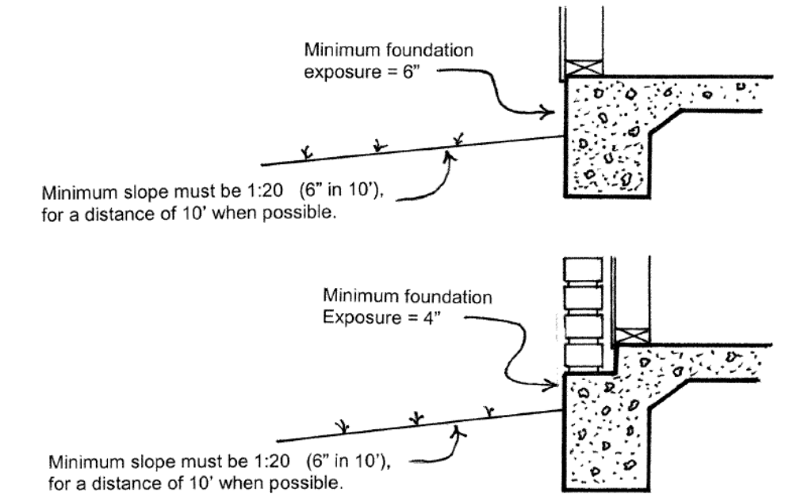

IBC SECTION 1807
FOUNDATION WALLS, RETAINING WALLS AND EMBEDDED POSTS AND POLES

*IBC Section 1807.2.4; added to read as follows:

1807.2.4 Material. Wood retaining walls exceeding four (4) feet in height shall be constructed of new wood properly treated for such use. Measurement shall be from the bottom of the footing to the top of the wall. See Section 105.2, item #4 for retaining walls in succession. See Section 1610.1.

IBC SECTION 1808
FOUNDATIONS

*IBC Section 1808.10; added to read as follows:

1808.10 Minimum distance of swimming pools from foundations. Swimming pools closer than 5’ to a nearby building foundation, measured from outside pool wall to the foundation, may not be closer than one horizontal foot at finish grade for every vertical foot of swimming pool depth.

Exception: Systems designed by an engineer registered in the State of Texas.

IBC SECTION 1809
SHALLOW FOUNDATIONS

*IBC Section 1809.7.1; added to read as follows:

1809.7.1 Alternate foundations. When engineered foundations are not required by other sections of this code, and unless in soils considered inadequate, as determined by the Building Official, for structures of standard construction, Figure No. 1809.7.1 may be accepted as an alternate foundation design for the occupancies and conditions specified.

FIGURE NO. 1809.7.1

*Figure No. 1809.7.1; added as follows:

FIGURE NO. 1809.7.1
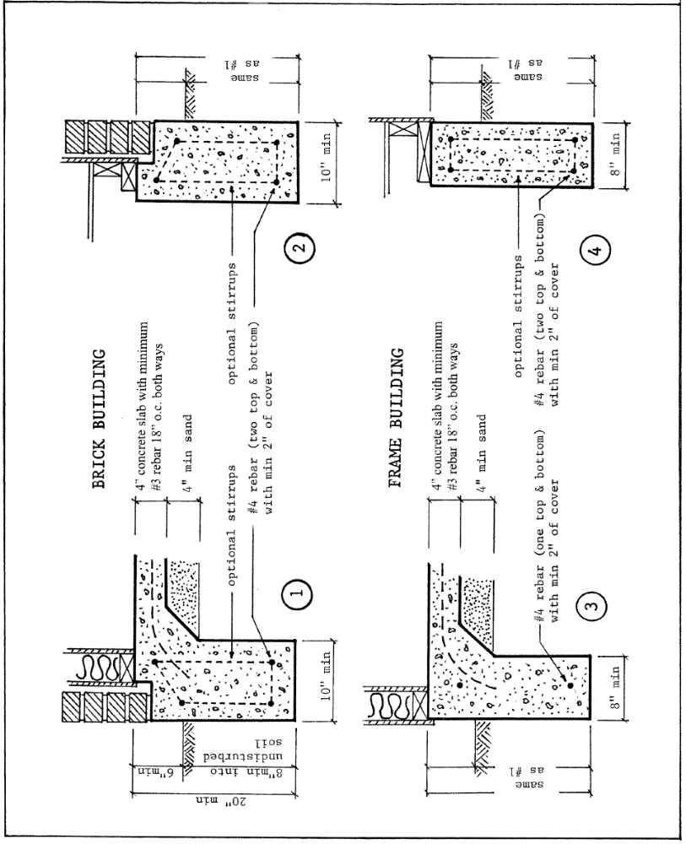
FIGURE NO. 1809.7.1 (cont.)
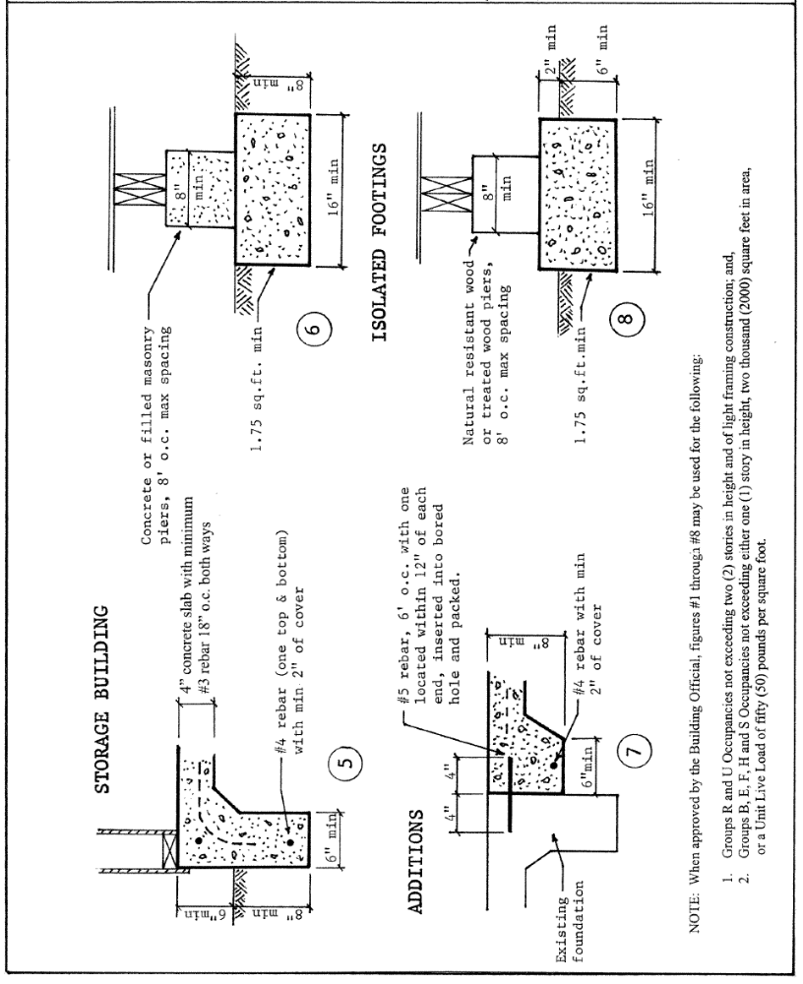

CHAPTER 23 - WOOD

IBC SECTION 2304
GENERAL CONSTRUCTION REQUIREMENTS

*IBC Section 2304.12.1.2.1; added to read as follows:

2304.12.1.2.1 Exterior bottom plates. All exterior wall bottom plates shall be of naturally durable or preservative-treated wood.

*IBC Section 2304.12.4; add an exception to read as follows:

Exception: When chemicals or other methods of protection are undesirable to the building owner/buyer provided an exposed exterior surface in compliance with Figure 1804.3 is provided.

IBC SECTION 2308
CONVENTIONAL LIGHT-FRAMED CONSTRUCTION

*IBC 2308.7.1; changed to read as follows:

2308.7.1 Ceiling joist spans. Spans for ceiling joists shall be in accordance with Table 2308.7.1(1) or 2308.7.1(2). Attic storage shall be considered another floor. (See definition of Attic). For other grades and species, and other loading conditions, refer to the AWC STJR.

Decking for equipment access and work area, as required in the Mechanical Code, shall comply with the decking requirements for a floor, or shall be a minimum of a single layer of ¾” plywood.

*IBC Section 2308.7.7; add an exception to read as follows:

Exception: When purlins are supported by struts to a joist in lieu of a bearing wall, such joists must be designed as a double floor joists for the span applied. Adequate bracing shall be provided to prevent rotation.

CHAPTER 24 – GLASS AND GLAZING

IBC SECTION 2406
SAFETY GLAZING

*IBC Section 2406.3; exception 1 is deleted.

CHAPTER 27 - ELECTRICAL

*IBC Chapter 27; changed to read as follows:

SECTION 2701
GENERAL

2701.1.1 COPS. For Critical Operations Power Systems necessary to maintain continuous power supply to facilities or parts of facilities that require continuous operation for the reasons of public safety, emergency management, national security, or business continuity, see the Electrical Code, Article 708.

CHAPTER 29 – PLUMBING SYSTEMS

IBC SECTION 2901
GENERAL

*IBC Section 2901.1; add a sentence to read as follows:

The provisions of this Chapter are meant to work in coordination with the provisions of Chapter 4 of the Plumbing Code. Should any conflicts arise between the two chapters, the Code Official shall determine which provision applies.

IBC SECTION 2902
MINIMUM PLUMBING FACILITIES

*IBC Section 2902.1; changed to read as follows:

2902.1 Minimum number of fixtures. Plumbing fixtures shall be provided for the type of occupancy and in the minimum number shown in Table 2902.1. based on the actual use of the building or space and as follows:

- Self-service storage facilities: shall be provided with one unisex accessible restroom for tenant usage.
- Each Recreational Vehicle Park, or portion of a Manufactured Home Park used for recreational vehicles, shall contain one (1) or more service buildings providing separate sanitary facilities for men and women.

a. No lot space shall be located farther than five hundred (500) feet from such a service building.

b. The entrances to such buildings shall be clearly marked to show which gender the facilities serve.

c. Fixtures shall be provided at the following ratio per twenty (20) lots or fraction thereof:

Toilets: Men (1) / Women (2)
Urinals: Men (1)
Lavatories: Men (1) / Women (1)
Showers: Men (1) / Women (1)

d. Each building providing sanitary fixtures shall contain at least one (1) slop sink.

e. If male and female sanitary facilities are housed within the same structure, they shall be separated by walls extending from the floor to the ceiling.

f. Toilets shall be located in separate compartments equipped with self-closing doors. Shower stalls shall be individual and equipped with self-closing doors. If dressing compartments are provided, each compartment shall be equipped with a stool or a bench. The rooms shall be screened to prevent direct view of the interior when the exterior doors are open.

Uses not shown in Table 2902.1 shall be considered individually by the code official. The number of occupants shall be determined by the code official. Occupancy classification shall be determined in accordance with this code. In other than E occupancies, the minimum number of fixtures in Table 2902.1 may be lowered, if requested in writing, by the applicant sating reasons for a reduced number and approved by the code official.

*IBC Table 2902.1; add a footnote "f" in the title and after the table as follows:

DRINKING FOUNTAINS (SEE SECITON 410 OF THE INTERNATIONAL PLUMBING CODE)^{f}

f. Drinking fountains are not required in M Occupancies with an occupant load of 100 or less, B Occupancies with an occupant load of 25 or less, and for dining and/or drinking establishments.

*IBC Section 2902.1.3; add new Section 2902.1.3 to read as follows:
2902.1.3 Additional fixtures for food preparation facilities. In addition to the fixtures required in this Chapter, all food service facilities shall be provided with additional fixtures set out in this section.

2902.1.3.1 Hand washing lavatory. At least one hand washing lavatory shall be provided for use by employees that is accessible from food preparation, food dispensing and ware washing areas. Additional hand washing lavatories may be required based on convenience of use by employees.

2902.1.3.2 Service sink. In new or remodeled food service establishments, at least one service sink or one floor sink shall be provided so that it is conveniently located for the cleaning of mops or similar wet floor cleaning tool and for the disposal of mop water and similar liquid waste. The location of the service sink(s) and/or mop sink(s) shall be approved by the City of Fort Worth Consumer Health Section.

*IBC Section 2902.2; changed to read as follows:

2902.2 Separate facilities. Where plumbing fixtures are required, separate facilities shall be provided for each sex.

Exceptions:
- Separate facilities shall not be required for private dwelling units or sleeping units.
- Separate facilities shall not be required in structures or tenant spaces with a total occupant load, including both employees and customers, of 50 15 or less.
- Separate facilities shall not be required in mercantile occupancies in which the maximum occupant load is 100 or less.
- Self-service storage facilities need only provide one unisex restroom for storage tenant usage. A single unisex employee restroom, when permitted and when accessible by the tenants, may count for such restroom. Such restroom shall be located near the facility entrance. Spaces converted to uses other than self-service storage shall comply with other applicable restroom provisions for that individual space.
- Aircraft T-hangar facilities need not install tenant restrooms when in compliance with the following:
  - Each such tenant hangar space is less than 2,000 square feet in area.
  - There are restrooms located within 500 feet of the lease space.

*IPC Section 2902.3; change to read as follows:

2902.3 Required public toilet facilities. Customers, patrons, and visitors shall be provided with public toilet facilities in structures and tenant spaces intended for public utilization. Facilities for public and employee use may be located in adjacent structures on the same property and under the same ownership, lease or control. The number of plumbing fixtures located within the required toilet facilities shall be provided in accordance with section 403 for all users. Employees shall be provided with toilets facilities in all occupancies. Employee toilet facilities shall be either separate or combined employee and public toilet facilities.

Exceptions: {unchanged}

CHAPTER 30 – ELEVATORS AND CONVEYING SYSTEMS

IBC SECTION 3001
GENERAL

*IBC Section 3001.5; added to read as follows:

3001.5 General. The owner shall be responsible for the safe operation and maintenance of each elevator, dumbwaiter, escalator or moving walk installation and shall cause periodic inspections, tests and maintenance to be made on such conveyances.

SECTION 3002
HOISTWAY ENCLOSURES

*IBC Section 3002.10, 3002.10.1, 3002.10.2 and 3002.11; added to read as follows:

3002.10 Pits. (ASME A17.1 – Section 2.2.1; Inquiry 07-50) A pit shall be provided for each individual elevator.

3002.10.1 Drainage. (ASME A17.1 – Section 2.2.2.3 thru 2.2.2.6)

      - Permanent provisions shall be made to prevent accumulation of ground water in the pit.
      - Drains and sump pumps, where provided, shall comply with the applicable plumbing code, and they shall be provided with a positive means to prevent water, gases, and odors from entering the hoistway.
      - In elevators provided with Firefighters’ Emergency Operation, a drain or sump pump shall be provided. The sump pump/drain shall have the capacity to remove a minimum of 11.4 m³/h (3,000 gal/h) per elevator.
      - Sumps and sump pumps in pits, where provide, shall be covered. The cover shall be secured and level with the pit floor.

3002.10.2 Discharge. When drainage is installed, whether required or voluntary, discharge shall comply with the following:

- Where there is no expectation of hydraulic fluid or oil contamination, the drainage may discharge into the sanitary sewer system, subject to the approval of the Water Department Pre-treatment Division.
- If installed in a location with possible contamination, a trap or interceptor rated for the expected flow rate with a minimum “storage” capacity equivalent to the volume of hydraulic fluid or oil that could be leaked into the drain, will be required prior to discharge into the sanitary sewer, subject to the approval of the Water Department Pre-treatment Division.
- In either situation, discharge to the storm drainage system is not permitted.
- Gravity drains that comply with the above provisions should be discussed with the Chief Plumbing Inspector before installation.
- Drainage to a storage tank is not permitted without specific approval. Overflow of such tanks shall be in compliance with the provisions listed in items 1 through 3 above.

3002.11 Other pipes, ducts or electrical wiring. See Sections 3004.4 and 3006.6 and the following:

(ASME A17.1 – Section 2.8.2.2) Only such electrical wiring, raceways, cables, coaxial wiring, and antennas used directly in connection with the elevator, including wiring for signals, for communication with the car, for lighting, heating, air conditioning, and ventilating the car, for fire detecting systems, for pit sump pumps, and for heating and lighting the hoistway and/or the machinery space, machine room, control space, or control room shall be permitted to be installed inside the hoistway, machinery space, machine room, control space, or control room.

(ASME A17.1 – Section 2.8.3.4) Other pipes or ducts conveying gases, vapors, or liquid and not used in connection with the operation of the elevator shall not be installed in any hoistway, machinery space, machine room, control space or control room.

IBC SECTION 3005
MACHINE ROOM

*IBC Section 3005.1; add two sentences to read as follows:

Elevator machine rooms shall be provided. All elevator control circuit boards, switch gears, etc. that is necessary to maintain the operation of the elevator during an emergency event shall be located within the machine room or inside the elevator hoistway if not prohibited by other provisions.

*IBC Section 3005.4; delete the two exceptions

*IBC Section 3005.5; deleted.

*IBC Section 3005.7; added to read as follows:

[F] 3005.7 Fire Protection in Machine rooms, control rooms, machinery spaces and control spaces. Fire protection in machine rooms, control rooms, machinery spaces and controls paces shall comply with section 3005.7.1 through 3005.7.4

[F] 3005.7.1 Automatic sprinkler system. The building shall be equipped throughout with an automatic sprinkler system in accordance with Section 903.3.1.1, except as otherwise permitted by Section 903.3.1.1.1 and as prohibited by Section 3005.7.2.1.

[F] 3005.7.2.1 Prohibited locations. Automatic sprinklers shall not be installed in machine rooms, elevator machinery spaces, control rooms, control spaces and elevator hoist-ways.

[F] 3005.7.2.2 Sprinkler system monitoring. The sprinkler system shall have a sprinkler control valve supervisory switch and water-flow initiating device provided for each floor that is monitored by the building’s fire alarm system.

[F] 3005.7.3 Water protection. An approved method to prevent water from infiltrating into the hoistway enclosure from the operation of the automatic sprinkler system outside the elevator lobby shall be provided.

[F] 3005.7.4 Shunt trip. Means for elevator shutdown in accordance with Section 3005.5 shall not be installed.

IBC SECTION 3007
FIRE SERVICE ACCESS ELEVATOR

*IBC Section 3007.6; amended and new Section 3007.6.6 added to read as follows:

3007.6 Fire service access elevator lobby. The fire service access elevator shall open into a fire service access elevator lobby in accordance with Sections 3007.4.1 through 3007.4.4 3007.6.6.

[F] 3007.6.6 Storage and furniture. Where fire service access elevators are required, fire service access elevator lobbies shall be maintained free of storage and furniture. See Fire Code Section 607.

CHAPTER 31 – SPECIAL CONSTRUCTION

IBC SECTION 3102
MEMBRANE STRUCTURES

*IBC Section 3102.1; add a sentence to read as follows:

Subject to approval of the building official and fire code official, such structures erected on a building, balcony or deck may also be considered as a Tent, as defined in the Fire Code, and in compliance with Chapter 24 of the Fire Code

*IBC Section 3102.4.1; added to read as follows:

3102.4.1 Membrane Covered Parking Structures. As an alternate to the provisions of this code, membrane parking structures may comply with all of the following:

- Must pass NFPA 701.
- Maximum area per structure of combination of structures considered as one building does not exceed 12,000 sq.ft.
- The covered structure is separated from other structures and any other building on the same property by a minimum of 20’.
- The covered structure is separated from the property line or center line of public way of at least 10’.
- The structure will be considered a Type V-B enclosed parking garage.

IBC SECTION 3103
TEMPORARY STRUCTURES

*IBC Section 3103; delete.

IBC SECTION 3109
SWIMMING POOL ENCLOSURES AND SAFETY DEVICES

*IBC Section 3109; delete and replace to read as follows:

3109.1 General. Swimming pools shall comply with the requirements of Section 3109.1.1 through 3109.5 and other applicable sections of this code.

The provisions of this section may be enforced by other code enforcement divisions of this city but interpretation authority shall be retained by the building official.

3109.1.1 Existing pools. Compliance for existing swimming pools shall be as listed below:

- For pools constructed on or after October 1, 1993 for use with Group R, Division 3 Occupancies, see the appropriate provisions in the code in effect when the pool was constructed as follows:
- 12-4-98 to 7-1-01, see 1997 UBC, Appendix Chapter 4 with amendments - Ord 13625.
- 7-1-01 to 12-31-2016, see IBC Chapter 31 and IRC Appendix Chapter G with amendments, as adopted at time of constructed.
- 1-1-2017 to present, see IBC Chapter 31 and IRC Appendix Chapter Q with amendments, as adopted at time of constructed.

- For pools owned, controlled, or maintained by the owner of a multiunit rental complex or by a property owners association, see the appropriate state law. Primary enforcement authority is by the Consumer Health Section of the Code Compliance Department.

- For public pools, see the appropriate state law. Primary enforcement authority is by the Consumer Health Section of the Code Compliance Department.

- For all other existing pools not covered by items 1, 2 or 3 above, regardless of date of installation, see Section 3109.6.

3109.2 Definitions. The following terms are defined in Chapter 2:

BARRIER.

SWIMMING POOL, INDOOR.

SWIMMING POOL, OUTDOOR.

3109.3 Public swimming pools. Public swimming pools shall be completely enclosed by a fence in accordance with the applicable State Law or ordinance enforced by the Health Department, but shall be a minimum of at least 4 feet (1290 mm) in height or a screen enclosure. Openings in the fence shall not permit the passage of a 4-inch-diameter (201 mm) sphere. The fence or screen enclosure shall be equipped with self-closing and self-latching gates.

3109.4 Residential swimming pools. Residential swimming pools shall comply as follows:
  - Residential pools qualifying as public pools under State Law, shall comply with Section 3109.3.
  - Multi-family swimming pools shall comply with the applicable State Law or ordinance enforced by the Health Department.
  - Pools associated with one- and two-family dwellings and townhouses under the Residential Code, shall comply with Appendix Q of that code.
  - All other residential swimming pools shall be completely enclosed by a barrier complying with Sections 3109.4.1 through 3109.4.3.

Exception: A swimming pool with a power safety cover or spa with a safety cover complying with ASTM F 1346 need not comply with this section.

3109.4.1 Barrier height and clearances. The top of the barrier shall be at least 48 inches (1219mm) above grade measured on the side of the barrier, which faces away from the swimming pool. The maximum vertical clearance between grade and the bottom of the barrier shall be 2 inches (51mm) measured on the side of the barrier, which faces away from the swimming pool. Where the top of the pool structure is above grade, such as an above-ground pool, the barrier may be at ground level, such as the pool structure, or mounted on top of the pool structure. Where the barrier is mounted on top of the pool structure, the maximum vertical clearance between the top of the pool structure and the bottom of the barrier shall be 4 inches (102mm).

Exceptions:
- The side of an outdoor swimming pool facing a private golf course of other restricted access area where the erection of barriers is prohibited by deed restrictions need not have a barrier on that side.
- Natural topographical barriers such as lakes, rivers, retaining walls, impenetrable hedges, and inaccessible inclines may be substituted as part of the barrier.

3109.4.1.1 Openings. Openings in the barrier shall not allow passage of a 4-inch-diameter (102mm) sphere.

3109.4.1.2 Solid barrier surfaces. Solid barriers which do not have openings, such as a masonry or stone wall, shall not contain indentations or protrusions that form handholds or footholds, except for normal construction tolerances and tooled masonry joints.

3109.4.1.3 Closely spaced horizontal members. Where the barrier is composed of horizontal and vertical members and the distance between the tops of the horizontal members is less than 45 inches (1143mm), the horizontal members shall be located on the swimming pool side of the fence. Spacing between vertical members shall not exceed 1.75 inches (44mm) in width. Where there are decorative cutouts within vertical members, spacing within the cutouts shall not exceed 1.75 inches (44 mm) in width.

Exception: When horizontal members are part of a fence that is at least 6 feet (1830 mm) in height, the horizontal members need not be on the pool side of the barrier.

3109.4.1.4 Widely spaced horizontal members. Where the barrier is composed of horizontal and vertical members and the distance between the tops of the horizontal members is 45 inches (1143 mm) or more, spacing between vertical members shall not exceed 4 inches (102 mm). Where there are decorative cutouts within vertical members, spacing within the cutouts shall not exceed 1.75 inches (44 mm) in width.

3109.4.1.5 Chain link dimensions. Maximum mesh size for chain link fences shall be a 2.25-inch (57 mm) square unless the fence is provided with slats fastened at the top or the bottom which reduce the openings to not more than 1.75 inches (44 mm).

3104.1.6 Diagonal members. Where the barrier is composed of diagonal members, such as a lattice fence, the maximum opening formed by the diagonal members shall not be more than 1.75 inches (44 mm).

3104.1.7 Gates. Access doors or gates shall comply with the requirements of Section 3109.4.1.1 through 3109.4.1.6 and shall be equipped to accommodate a locking device. Pedestrian access doors or gates shall open outward away from the pool and shall be self-closing and have a self-latching device. Doors or gates other than pedestrian access doors or gates shall have a self-latching device. Release mechanisms shall be in accordance with Sections 1010.1.9 and 1109.13. Where the release mechanism of the self-latching device is located less than 54 inches (1372 mm) from the bottom of the door or gate, the release mechanism shall be located on the pool side of the door or gate 3 inches (76 mm) or more, below the top of the door or gate, and the door or gate and barrier shall be without openings greater than 0.5 inch (13 mm) within 18 inches (457 mm) of the release mechanism.

3109.4.1.8 Dwelling wall as a barrier. Where a wall of a dwelling serves a part of the barrier one of the following conditions shall be apply:

  - Operable windows having a sill height of less than 48 inches (1219mm) above the indoor finished floor and doors with direct access to the pool or spa through that wall shall have an alarm that produces an audible warning when the window, door or their screens are opened. The alarm shall be listed and labeled as a water hazard entrance alarm in accordance with UL 2017. In dwelling units or structures not required to be Accessible units, Type A units or Type B units, the operable parts of the alarm deactivation switches shall be located 54 inches (1371mm) or more above the finished floor. In dwellings or structures required to be accessible unites, Type A units or Type B units, the operable parts of the alarm deactivation switches shall be located not greater than 54 inches (1372 mm) and not less than 48 inches (1219 mm) above the finished floor.
  - A safety cover that is listed and labeled in compliance with ASTM F1346 is installed for the poos or spa; or
  - An approved means of protection, such as self-closing doors with self-latching devices, is provided. Such means of protection shall provide a degree of protection that is not less than the protection afforded by Item 9.1 or 9.2 described above.

3109.4.1.9 Pool structure as barrier. Where an above-ground pool structure is used as a barrier or where the barrier is mounted on top of the pool structure, the top of the barrier is not less than 48 inches (1219 mm) above grade for the entire perimeter of the pool, and the means of access is a ladder or steps, then the ladder or steps either

shall be capable of being secured, locked or removed to prevent access, or the ladder or steps shall be surrounded by a barrier which meets the requirements of Section 3109.4.1.1 through 3109.4.1.8. When the ladder or steps are secured, locked or removed, any opening created shall not allow the passage of a 4-inchdiameter (102 mm) sphere.

3109.4.2 Indoor Swimming pools. Walls surrounding indoor swimming pools shall not be required to comply with Section 3109.4.1.8

3109.5 Entrapment avoidance. For pools under the authority of the Health Department, entrapment protection shall be provided as required by State Law or ordinance as enforced by the Health Department. Otherwise, suction Suction outlets shall be designed and installed in accordance with ANSI/APSP-7.

3109.6 Existing pools. Pools in existence that are not covered by any ordinance listed in Section 3109.1 shall comply with this section.

3109.6.1 Barrier height. Pools shall be completely enclosed by a fence at least 4 feet (1290 mm) in height or a screen enclosure. Such barrier shall comply with provisions of the zoning ordinance and other applicable city codes and ordinances.

A wall of a dwelling or structure is permitted to serve as part of the barrier. Natural topographical barriers such as lakes, rivers, retaining walls, impenetrable hedges, and inaccessible inclines may be substituted as part of the barrier.

3109.6.2 Openings. Openings in the fence shall not permit the passage of a 4-inch (102 mm) diameter sphere.

3109.6.3 Gates. The fence or screen enclosure shall be equipped with self-closing and self-latching gates. Pedestrian access gates shall open outward away from the pool. All gates or doors opening through such barriers shall be equipped with a device for keeping the gate or door securely closed at all times when not in actual use, except that the door of any dwelling or dwelling unit which forms a part of the barrier need not be so equipped. Such closure device shall be attached not less than forty (40) inches above grade. Such gates or doors shall be kept securely closed at all times when not in actual use.

Temporary access through a barrier may be permitted during construction if a temporary barrier is provided during times when such access is not in use.

3109.6.4 Responsibility. No person in possession of land within the city, either as owner, purchaser, lessee, tenant or licensee, upon which is situated an outdoor swimming pool, shall fail to provide a barrier as herein provided.

3109.6.5 Exemptions. The following are exempt from the barrier requirements of this sub-section:

- Indoor swimming pools.

- Outdoor swimming pools less than twenty-four (24) inches in depth.

- Outdoor swimming pools where the pool decking or pool top is at least forty-six (46) inches higher than adjoining grade, provided that their access ladder or steps can be locked or blocked in a manner approved by the Building Official when such ladder or steps are not in use.

- The side of an outdoor swimming pool facing a private golf course of other restricted access area where the erection of barriers is prohibited by deed restrictions.

- Portable spas or portable hot tubs with safety covers of a type approved by the Building Official.

CHAPTER 32 - ENCROACHMENT INTO THE PUBLIC RIGHT-OF-WAY

IBC SECTION 3201
GENERAL

*IBC Section 3201.1; add a sentence to read as follows:

Encroachments shall require an executed agreement as required by Division II or Division III of this Chapter.

*IBC Section 3201.5; added to read as follows:

3201.5 Projections. The projection limitations specified in Section 3202 shall be applied when determined as necessary by the building official during the encroachment review process. Any encroachment approved by City Council may project further than listed herein.

IBC SECTION 3202
ENCROACHMENTS

*IBC Section 3202.2; changed to read as follows:

3202.2 Encroachments above grade and below 8 feet in height. Encroachments into the public right-of-way above grade and below 8 feet (2438 mm) in height shall be prohibited except as provided for in Sections 3202.2.1 through 2302.2.4. Doors and windows shall not open or project into the public right-of-way.

*IBC Section 3202.2.4; added to read as follows:

3202.2.4 Doors and windows. Doors and windows encroaching into the right of way shall be approved by the Transportation/Public Works department.

*IBC Section 3202.4; delete.

*IBC Chapter 32, Divisions II and III; added to read as follows:

Division II
Encroachment of Public Property

TEMPORARY ENCROACHMENTS

3203 General. No person, firm, or corporation shall use or occupy a public Right Of Way, inclusive of street area, alley area, or sidewalk area without first complying with the requirements of this chapter.

Exceptions: 1. Use of public property for work that does not fall under the jurisdiction of the Building, Energy, Electrical, Mechanical, Plumbing, Residential or Sign Codes.
2. Entire street widths may be approved for closure by the Director of Transportation and Public Works, provided the length of time does not exceed one 8-hour day. For this purpose, no encroachment is required under this chapter.
3. For Sidewalk Cafes, see City Code, Chapter 20, Article IX, “Sidewalk Cafes,” and Section 111.6.2 of the Fort Worth Building Administrative Code.

Temporary encroachments may be used to permit the temporary use of public property for other purposes besides construction or demolition. The Department of Transportation/Public Works in these cases shall formulate a policy covering such use.

3204 - Permit Required

3204 General. Temporary encroachment of public property shall not occur until the applicant executes a Temporary Consent Agreement with the City and obtains an Encroachment Permit from the Building Official.

3204.1 Temporary Consent Agreement. The applicant shall execute three (3) copies of a Consent Agreement with the City upon forms furnished by the Building Official. The forms for such agreement shall be approved from time to time by the City Attorney. Executed forms shall be kept and made available in the offices of the Building Official and City Secretary.

3204.2 Liability Insurance. The Temporary Consent Agreements shall be accompanied by proof that the applicant has secured and paid for a policy of public liability insurance covering all public risks related to the proposed use and occupancy of public property as described in the agreement and permits. The amount of insurance coverage shall be at least the maximum amounts of liability which can be imposed upon the City under State law.

Each such insurance policy shall provide that it cannot be canceled or amended without at least ten (10) days advance written notice to the City. Insurance shall be maintained for the length of encroachment.

3204.3 Plans. Each Temporary Consent Agreement shall be accompanied by a plan showing the location and amount of public property to be occupied; the location of all railings, fences, canopies and construction offices, sheds and other appurtenances; and the nature and location of all warning devices necessary to protect pedestrian and vehicular traffic.

The Encroachment Permit shall not be considered as a construction permit for the items required to be shown on the plan except those required for pedestrian protection as required by Chapter 33.

3204.4 Permit Fee. The applicant shall pay a permit fee based upon the area used and the expected length of use as specified in Fort Worth Building Administrative Code

If the length of time is underestimated, an additional permit fee will be required. If the fee is paid before the permit expires, the permit can be extended. If after the permit expires, a new permit must be applied for.

The area for consideration includes all areas removed from public use, inclusive of traffic barricade areas.

3204.5 Issuance. The Building Official shall issue an Encroachment Permit when the applicant has complied with all the provisions of this chapter.

3205 Refund. If the length of time is overestimated, the Building Official shall, upon requests, calculate the permit fee based upon the actual number of days and return any overages to the applicant except that a minimum of the amounts listed in Section 3204.4 per permit will be kept.

3206 Inspections. An inspection must be obtained after all barricades, fences, railings and other forms of pedestrian and vehicular protection are in place. A final inspection must be obtained after all such items are removed.

3207 - Building Official Authority

3207 General. The Building Official is hereby authorized to execute the Encroachment Agreement on behalf of the City for temporary use or occupancy of public property for areas as listed in this section. Areas larger than those specified herein will require City Council approval before the Agreement can be executed.

3207.1 Area. The Building Official and the Director of Transportation and Public Works shall determine the area of street, alley or public sidewalk which may be used during the construction or demolition period for work space and for storage of materials and equipment. Such area shall be based upon the actual need of the builder, with due consideration being given to public inconvenience.

The area allowed for use without requiring City Council approval shall be as follows:

- Not more than two (2)-lanes of a four (4)-lane street; nor one (1)-lane of a two (2)-lane street; nor one (1)-lane of a one way street may be blocked.

- Alleys adjoining a building site provided that a clear and unobstructed roadway of not less than 10 feet in width is maintained through such alley if such roadway is required for use by fire trucks, garbage trucks or for access to public utilities or other buildings on the alley.

- Any portion of a public sidewalk adjoining a building site except the walkway area required to be maintained for public use.

- Not withstanding the above provisions, no use will be authorized within 8 feet 6 inches of the center line of any railway track.

3208 - Special Provisions

3208.1 Earth and Rubbish. Earth or other waste material taken from buildings shall not be stored either upon sidewalks or streets, but shall be removed therefrom each day upon accumulation. When dry rubbish is being handled, same shall be wetted so as to prevent dust and blowing debris.

3208.2 Demolition. No wrecked or waste materials shall be placed upon any floor of any building during the course of demolition so as to cause the overloading of such floor. Such materials shall be lowered to the ground immediately upon displacement. No material shall be thrown from a building to a sidewalk or pavement but shall be conveyed to the ground by properly constructed chutes.

Blasting, pulling or throwing of masonry walls shall not be permitted except in emergencies as approved by the Fire Chief and the Building Official.

Division III
Encroachment of Public Property

PERMANENT ENCROACHMENTS

3209 General. No part of any building or structure, or any appendage thereto, that is not in compliance with the provisions of this chapter shall project into public property.

Exceptions: 1. Gratings over openings in public property which have openings not exceeding 7/16 inch and are designed to withstand loads in excess of 150 pounds psf may permanently occupy public property.
2. Environmental monitoring wells when approved by the authority authorized to the Environmental Management Department.
3. Backflow protection devices when approved by the authority authorized to the Water Department.

3210 - Consent Agreements

3210.1 General. All permanent encroachments into public property shall require a duly executed Consent Agreement approved by City Council.

Exceptions: 1. The Building Official is hereby authorized to execute Consent Agreements on behalf of the City covering signs that do not project more than two (2) feet over public property when all requirements of this Code, the Sign Code and the Comprehensive Zoning Code have been satisfied.
2. The Planning and Development Director is hereby authorized to execute Consent Agreements on behalf of the City, except as provided in Exception #1 above, when the encroachment beyond the property line extends no closer than within 18 inches of the face of the curb.

3210.2 Application. The applicant shall execute three (3) copies of a Consent Agreement with the City upon forms furnished by the Building Official. The forms for such agreement shall be approved from time to time by the City Attorney. Executed forms shall be kept and made available in the offices of the Building Official and City Secretary.

3210.3 Insurance. The Consent Agreements shall be accompanied by proof that the applicant has secured and paid for a policy of public liability insurance covering all public property as described in the Agreement. The amount of insurance coverage shall be at least the maximum amounts of liability which can be imposed upon the City under State law.

Each insurance policy shall provide that it cannot be canceled or amended without at least ten (10) days advanced written notice to the City. Insurance shall be maintained for the length of the encroachment.

3210.4 Plans. Each Consent Agreement shall be accompanied by a plan showing the location and amount of public property to be occupied with details of the structure of encroachment.

3210.5 Fee. Along with the Consent Agreements the applicant shall pay a non-refundable application fee as specified in Section 119, Table 1-F.

3211 Permits. Approval of the Consent Agreement does not eliminate the need for proper permits to do work as required by any code of the City. No work may commence without a permit as required by appropriate codes.

3212 Signs. Advertising signs projecting into public property are to be considered a permanent occupancy of public property.

Exception: An identification sign displayed as part of the marquee, provided the sign contains no off-premise advertising, is displayed to identify or locate the building or place of business and the height of the message does not exceed three (3) feet.

Signs that are covered by existing Consent Agreements shall have those Consent Agreements become null and void when a sign is altered in size, removed or requires structural repair.

CHAPTER 33 – SAFEGUARDS DURING CONSTRUCTION

IBC SECTION 3305
SANITARY

*IBC Section 3305.1; changed to read as follows:

3305.1 Facilities required. Sanitary facilities shall be provided for occupants and customers during construction, remodeling or demolition activities in accordance with the International Plumbing Code.

Exception: When the remodel includes the sanitary facilities, other facilities must be available or temporary facilities provided.

IBC SECTION 3306
PROTECTION OF PEDESTRIANS

*IBC Section 3306.1; add a second paragraph to read as follows:

When falling debris may, in the opinion of the Building Official, create a hazardous situation to pedestrians or motorist, barriers shall be required as specified in Section 3306.6.

*IBC Section 3306.2; add second paragraph to read as follows:

When authorization to close the sidewalk is obtained, the Building Official may permit a solid fence. The contractor shall place pedestrian warning signs on each side of the barricade at corners occupied by said barricades. The pedestrian signs shall read as follows:

WARNING
“Pedestrians are required by law to use
the opposite side of the street.”

WARNING
“No Parking or Standing of Vehicles.”

CHAPTER 35 – REFERENCED STANDARDS

*IBC Chapter 35, “Referenced Standards”; amend the standards listed below to read as follows:

National Fire Protection Association
1 Batterymarch Park
Quincy, MA 02169-7471
NFPA

Standard Referenced
reference in code
number Title section number

72-07 10 National Fire Alarm Code . . . . . . . . . . . 901.6, 903.4.1, 904.3.5, 907.2, 907.2.5, 907.2.11, 907.2.13.2,
907.3, 907.3.3, 907.3.4, 907.5.2.1.2, 907.5.2.2, 907.6, 907.6.1,
907.6.5, 907.7, 907.7.1, 907.7.2, 911.1.5, 3006.5, 3007.6

CHAPTER 36- DOCKS, PIERS AND BOATHOUSES

*Chapter 36; added to read as follows:

Chapter 36
Docks, Piers and Boathouses

IBC SECTION 3601
General

3601 General. The provisions of this Chapter shall apply to any body of water within the corporate limits of Fort Worth that is under the jurisdiction and control of the City of Fort Worth. In the absence of other provisions, this chapter may be used on bodies of water not under the control of the City of Fort Worth.

This chapter and the “Docks, Piers and Boat House” standards, adopted elsewhere, may be more stringent than other provisions of this code and other codes.

3601.1 Variances/Water Department Release. Lake Worth is owned by the City of Fort Worth. The Fort Worth Water Department has the charge for the safety of the water, as well as, safe usage of the water system. As such, some provisions in this chapter shall be designated as a regulation from the Water Department and will be identified as (WD). Any such section identified with (WD) cannot be granted a variance by the Construction and Fire Prevention Board without first obtaining a release from the Director of the Water Department.

IBC SECTION 3602
Definitions

3602 Definitions. The following words and terms shall, for the purposes of this chapter, have the meanings shown herein.

DEAD LOAD. The permanent inert weight of materials of construction incorporated into the structure, including fixed or permanent attachments, such as bumpers, railings, winch stands, roof structures, etc.

As further defined in Chapter 16, the weight of materials of construction incorporated into the building, including but not limited to walls, floors, roofs, ceilings, stairways, built-in partitions, finishes, cladding and other similarly incorporated architectural and structural items, and fixed service equipment including the weight of cranes. All dead loads are considered permanent loads.

DECKING. The surface material that forms the floor of the structure.

As further defined in Chapter 16, an exterior floor supported on at least two opposing sides by an adjacent structure, and/or posts, piers or other independent supports.

DOCK, PIER, OR BOAT HOUSE (or any combination). A structure extending from the shore into the water to permit the landing and mooring of vessels. The term “dock”, “pier” or “boat house” includes the anchoring system and any walkways or bridges that will attach to the structure itself.

HUNT ABSORPTION TEST. A test documenting the rate at which flotation material absorbs liquid, as well as the quantity of liquid absorbed.

LAKEFRONT PROPERTY LINE. The property line that borders the regulated water area. (For Lake Worth, “as shown on the final plat of record or survey for the property”.)

LAKE WORTH MANAGEMENT OFFICE (LWMO). That group in the Water and Property Management Departments responsible for review and approval of improvements to structures, prior to permitting, at or in Lake Worth and who shall administer the requirements of those departments.

LIVE LOAD. Any moving or variable superimposed load on the structure.

As further defined in Chapter 16, those loads produced by the use and occupancy of the building or other structure and do not include construction or environmental loads such as wind load, snow load, rain load, earthquake load, flood load or dead load.

LOADS. Forces or other actions that result from the weight of building materials, occupants and their possessions, environmental effect, differential movement and restrained dimensional changes. Permanent loads are those loads in which variations over time are rare or of small magnitude, such as dead loads. All other loads are variable loads.

REGISTERED PROFESSIONAL ENGINEER (RPE). A professional engineer currently registered with the State of Texas as a professional engineer.

STRUCTURAL DEAD LOAD. The weight of the structure and its ability to support itself.

STRUCTURE. When used in this Chapter shall be inclusive of entire dock, pier or boat house, including the walkway, anchoring system, cables, floats, electrical, plumbing and any other related components or materials installed in conjunction with the construction, maintenance, or use of the dock.

WALKWAY (or BRIDGE). A passage that provides access from the land or a boat dock, marina, or other floating facility.

SECTION 3603
Permits

3603 Permit Required. No person shall erect, construct, enlarge, alter, or move any dock, pier, boathouse or combination to any body of water within the corporate limits of Fort Worth, that is under the jurisdiction and control of the City of Fort Worth, without complying with the provisions of this chapter.

Each application for a permit, together with plans for a dock, pier, boathouse, or any combination thereof shall be submitted as specified in Chapter 1 of this code and as may be specified in other City codes.

Where such structures are constructed on Lake Worth or any body of water subject to the jurisdiction of another department of the City of Fort Worth, the additional approval of such department shall be obtained.

Submittal of a permit application is not permission to begin work. Construction is not permitted to begin until a permit is ISSUED.

IBC SECTION 3604
Use

3604 Use. Docks, piers and boathouses for private use shall normally be classified as a Group U Occupancy. Other occupancies may be allowed when the use is permitted by the Zoning Ordinance, together with the approval of any other appropriate department of the City of Fort Worth, and the construction complies with this code for said use.

IBC SECTION 3605
Design and Design Loads.

3605.1 General. When designed by an RPE, the RPE shall apply the appropriate loads when doing calculations. Such factors shall include, but not be limited to:

- dead load
- live load
- roof load
- wind load and wave action; which should be considered as simultaneously applied
- when intended to have boats attached to the structure for storage, the effects of such estimated loads, such as wind and wave, on the boat that are transferred to the structure shall also be considered.
- when intended to have boats lifted out of the water, the effects of such estimated loads, such as wind on the boat and dead load of the boat, that are transferred to the structure shall also be included.
- surface areas at and above the water line, when authorized, including walls, screens, tarps, etc.
- except as allowed for in Section 3605.3, flotation devices shall be designed to withstand the same dead load and live load as a fixed structure.

3605.2 All Occupancies. Regardless of the occupancy category assigned, all structures shall comply with the following provisions:

a. Piles shall conform to Chapter 18 of this Code.

b. All docks, piers and boathouses shall be designed to withstand the loads as specified in Chapter 16 of this code, based upon the Occupancy classification as assigned by the Building Official.

Exception: Private residential structures, classified as a Group U, may use the design loads as specified in Section 3605.3.

c. (WD) Structures shall be able to withstand a minimum of two-foot high wave action at normal water levels. (For Lake Worth, up to 594 ft. above sea level.) Floating docks must be designed with anchorage footing and piers to remain in place without floating off at the high water levels (For Lake Worth, this will be 601 ft. above sea level.)

- (WD) Cables and chains used in anchoring systems shall be designed with a minimum working load safety factor of 3.0 for cable and 2.0 for chains.

e. (WD) Walkways and bridges shall have a maximum slope under dead load of a 4:1 ratio to any direction at the lowest expected water level. (For Lake Worth, 591 ft. above sea level.)

3605.3 Group U Occupancies. When private structures associated with residential uses are assigned a Group U Occupancy classification, the design provisions provided in Section 3605.3.1 through 3605.3.2, may be used in lieu of Chapter 16.

3605.3.1 Flotation devices shall be designed to support the dead load plus 30-pounds per square foot (PSF) live load applied to deck area.

3605.3.2 Structural frame shall be designed to support 40 pounds per square foot (PSF) live load applied to the full surface area of the deck.

IBC SECTION 3606
Construction

3606 Dock and Pier Construction. When not designed by an RPE, the proposed design shall incorporate the following minimum provisions:

3606.1 Piles. Wood piles shall be a minimum of six (6) inches in diameter. Metal piles shall be a minimum of three (3) inches inside diameter pipe. Such piles shall be driven to a minimum depth of twenty-four (24) inches below the top layer of silt. Such piles shall be driven in pairs, one on either side of the platform, and braced as required by section 3606.6. Such piles shall not be spaced apart more than ten (10) feet center to center.

3606.2 Box cribs. Sets of structural columns of the same size forming a box crib may be used. Such crib shall be braced as required in Section 3606.6 and anchored as required in Section 3607.

3606.3 Beams. Beams shall be defined as those members which connect to piles to support the stringers. All beams when of wood shall be a minimum 2-inch material.

3606.4 Stringers. Stringers shall be defined as those members usually supporting the decking. All stringers when of wood shall be of a minimum 2-inch material.

3606.5 Decking.

3606.5.1 Wooden platform decking shall be of a minimum nominal 2-inch material.

3606.5.2 Other materials, to include lightweight concrete or metal decking may be used when approved by the Building Official. Such decking shall meet the load requirements of Section 3605.

3606.6 Bracing.

3606.6.1 Materials. All wooden bracing shall be of a minimum nominal 2-inch x 6-inch material attached through the brace and supporting members with two (2) one half inch galvanized bolts. Steel tie rods shall be a minimum three quarter inch diameter galvanized that are fitted through drilled holes in the piles.

3606.6.2 Bracing shall be accomplished by one or more of the following methods:

- Cross or “X” bracing. Cross or “X” bracing at each set of piles and box cribs. The angle of the bracing shall be between 45 and 60 degrees off horizontal. Each member of the brace shall be placed on the outward facing portion of the pile.

b. Knee bracing. Knee bracing may be used on each pile attached to and paralleling the platform deck. The angle of the bracing shall be between 45 and 60 degrees off horizontal.

3606.7 Attachment of deck. Attachment of the platform deck to beams and piles shall be accomplished by attaching the beams to the piles and box cribs by a minimum of two (2) one half inch galvanized through bolts.

IBC SECTION 3607
Anchorage

3607 Anchorage of Floatation and box crib structures. Such structures shall be anchored with solid units that will provide the following anchorage:

- Docks and piers less than fifty (50) feet in length: An anchor on each corner that will support one-fourth of the total dead load plus one-eighth the total live load.

- Docks and piers fifty (50) feet or more in length: Anchors at the midpoint of the piers.

- All docks and piers shall be anchored to the shore line.

- All anchors shall be of masonry, concrete, or steel and shall be securely fastened to the dock or pier by rope, cable, chain, or other approved methods.

IBC SECTION 3608
Required Water Proofing.

3608.1 All wood below one (1) foot above spillway elevation on lakes (for Lake Worth, 595 feet) or below one (1) foot above the 50-year flood elevations on other bodies of water shall be treated lumber. Creosote is not allowed.

3608.2 All metal, including bolts, lag bolts, and fasteners, shall be galvanized zinc or other approved materials.

IBC SECTION 3609
Flotation Material

3609 Floatation Material. All flotation units shall adequately support the dead and live loads of all beams, stringers, and platforms. Data shall be submitted to and approved by the Building Official showing that the buoyancy of such units will support the loads imposed.

Only flotation units made of materials which will not affect the water quality in any way may be used. Flotation units shall be constructed of material that has never been used in any manner for storage of toxic or hazardous material. Proof that the flotation units meet the requirements must be provided to and approved by the Building Official.

- (WD) Flotation material shall be extruded polystyrene, expanded polystyrene, or a copolymer of polyethylene and polystyrene and shall have a minimum density of 0.9 pounds per cubic foot, and be of consistent quality throughout the float. Beads shall be firmly fused together, and there shall be no voids inside the encasement. Flotation material shall have a water rate absorption of less than 3.0 pounds per cubic foot over seven (7) days when tested by the Hunt Absorption Test. Other flotation material may be considered if it meets all of the requirements set forth in this chapter.

- (WD) Flotation material shall be encased in solid polyethylene or a polyurethane type coating, both of which shall be watertight and have a nominal thickness of 0.125 inches.

- (WD) Drums made of plastic, whether new or recycled, or metal shall not be used for encasements or floats.

- (WD) Materials which are considered unacceptable for this purpose include but are not limited to standard steel 55 gallon drums, any metal which may corrode in the aqueous environment, and any material which may release toxic or hazardous material into the lake proper.

- (WD) All flats shall be warranted for a minimum of eight (8) years against sinking, becoming waterlogged, cracking, peeling, fragmenting, or losing beads, and shall not be prone to damage by animals.

- (WD) Floats that are punctured, exposing the foam to erosion or deterioration, shall be replaced immediately.

IBC SECTION 3610
Boathouses

3610 Boathouse construction. Construction of boathouses or other structures shall meet or exceed the requirements for framing and coverage as specified in other parts of this code. When, in the opinion of the Building Official, the load of the intended use exceeds the capability of the minimum construction design specified, plans and specification may be required to be designed by a Registered Professional Engineer (RPE).

IBC SECTION 3611
Prohibited uses

3611.1 (WD) Toilet facilities. No toilet facilities of any type shall be allowed on any Structure built past the Lakefront Property Line.

3611.2 (WD) Fuel pumping. Fuel pumping facilities exceeding 55 gallons are not allowed on structures that extend past the Lakefront Property Line.

IBC SECTION 3612
Safety devices

3612.1 (WD) Photocell light. Any Structure that extends more than 100 feet from the Lakefront Property Line shall be equipped with a white photocell light of no less than 200 lumens that operates continually from dusk to dawn. Such lighting shall be provided with a cover on the top of the light to minimize light dispersion upward and toward the shore. The LWMO may require that lighting be placed on structures less than 100 feet from the shoreline when in LWMO decides it is warranted to enhance boating safety. It is the Dock owner's responsibility to ensure that all required lighting is properly maintained and operational at all times.

3612.2 (WD) Water supply A potable water supply can be plumbed to the first floor (lower deck) provided that backflow prevention devices are installed and inspected in accordance with 12.5, Article V, Division 3, Cross Connection Control of the City Code and the Plumbing Code as adopted by the City Council.

APPENDIX L

*IBC Appendix L, added to read as follows:

IBC APPENDIX L

INTERIOR ENVORONMENT
DIVISION II

SOUND INSULATION REQUIREMENTS FOR NOISE
SENSITIVE USES NEAR AIRPORTS

SECTION L1212
GENERAL

L1212.1 Scope. The regulations and requirements shall apply to all new residential buildings and new noise-sensitive non-residential buildings, as defined herein, that are located wholly or partially within the boundaries of the 65 DNL or greater noise contours as designated in Figure L1212.1(1).

The term “new” shall apply to new detached buildings built after the effective date of this ordinance, and shall include later additions or modifications to those same buildings. The term shall also include a Change of Occupancy in existing buildings from a non-protected occupancy to one of the protected occupancies listed herein.

Buildings in existence prior to the effective date, and additions to or modifications of those same buildings, shall not be required to comply, except when a Change of Occupancy from a non-protected occupancy to one of the protected uses is involved.

SECTION L1213
DEFINITIONS

L1213.1 General. The following words and terms shall, for the purposes of this chapter and as used elsewhere in this code, have the meanings shown herein.

Aircraft noise – is generally expressed in terms of it’s A-weighted sound level, in units called “decibels.” Strictly speaking, the decibel unit should be abbreviated only by “dB”; however, for clarity “dBA” and “dB(A)” are often used to highlight the fact that the sound level measurement has been A-weighted.

Noise exposure – in areas around airports is expressed in terms of the Day-Night Average Sound Level, which is abbreviated by “DNL” in text and “L_{dn}” in equations.

NOISE-SENSITIVE NON-RESIDENTIAL BUILDINGS –
- Nursing homes and hospitals, generally classified as Group I; and
- Child day care centers, Adult day care centers and schools, generally classified as Group E and Group I-4.

RESIDENTIAL STRUCTURES: Single-family, Two-family, Townhouse, Multi-family, and Assisted Living uses, generally classified as Group R, whether in a single occupancy or mixed occupancy.

Sound insulation properties – of building construction materials are described by Sound Transmission Loss (TL) or Sound Transmission Class (STC). The higher the TL or STC value, the less sound will be transmitted through the building material.

SECTION L1214
PURPOSE

L1214.1 General. All buildings and structures with protective uses, as applicable under this Division, shall be required to have minimum sound insulation standards and requirements to protect the persons within designated noise sensitive buildings from excessive exterior noise through regulation of design, construction and modification of such buildings. After proper sound insulation measures are taken, the interior sound level, attributable to exterior sources, shall not exceed 45 dB.

L1214.2 Protected Uses:
- Single-family, two-family, townhouse, multi-family, and Assisted Living uses, generally classified as Group R, whether in a single occupancy or mixed occupancy.
- Nursing homes and hospitals, generally classified as Group I; and
- Child day care centers, Adult day care centers and schools, generally classified as Group E and Group I-4.

All new construction with those uses, and any Change of Use to those uses, must comply with the sound reduction construction requirements.

Any option, door, window, or product that is not listed in this document may be used provided sufficient documentation is submitted to confirm appropriate testing to achieve the required STC rating.

SECTION L1215
BUILDING REQUIREMENTS

L1215.1 General. Compliance with the following prescriptive provisions shall be deemed to be in compliance with this Division.

Exception: In lieu of the prescriptive provisions listed below, an acoustical design may be submitted showing that the interior sound level, attributable to exterior sources, shall not exceed 45 dB. Such design must be prepared by a person experienced in the field of acoustical engineering or a registered architect. The design documentation with the appropriate seal shall be attached.

L1215.2 Building requirements for construction in the 65 dB Contour

L1215.2.1 Exterior Windows. Exterior windows must have STC rating 25 or greater, or approved for 65 dB or higher. If using other windows not listed in the tables, the applicant must provide acceptable manufacturer’s documentation on STC rating.

The total area of glazing in rooms used for sleeping shall not exceed 20 percent of the floor area.

L1215.2.2 Exterior walls. Exterior walls must have STC rating of 25 or greater, or approved for 65 dB or higher. Walls that are exterior of the protected use, but interior to the building, separating the protected use from the remainder area, such as, an enclosed garages, unused space, warehouse, etc., may be reduced to an STC of 20.

If using other walls not listed in the tables, the applicant must provide acceptable manufacturer’s documentation on STC rating.

L1215.2.3 Exterior Doors. Exterior doors must be STC rating 25 or greater, or approved for 65 dB or higher. Doors that are exterior of the protected use, but interior to the building, separating the protected use from the remainder area, such as, an enclosed garages, unused space, warehouse, etc., may be reduced to an STC of 20, or may use option Door 21, 22 or 23.

If using other doors not listed in the tables, applicant must provide acceptable manufacturer’s documentation on STC rating.

View windows in doors and sidelights shall comply with the Exterior Window provisions listed above, unless using door options Door 1a, 1b, 1c or 1d.

L1215.2.4 Roof/Ceiling. Roof/Ceiling assembly must be STC rating of 25 or greater, or approved for 65 dB or higher. If using other Roof/Ceiling assemblies not listed in the tables, the applicant must provide acceptable manufacturer’s documentation on STC rating.

- An accessible attic space shall be provided above rooms on the uppermost level of Group R buildings.
- Attic insulation shall be batt or blown-in glass fiber or mineral wool with a minimum R-value as required by the Energy Code, but not less than R-30 rating applied between the ceiling joists.
- Attic ventilation, when installed, shall be:
1. Gable vents or other attic vents that penetrate the attic enclosure shall be fitted with a ½" plywood panel, with 1" semi-rigid insulation attached to the surface facing the vent, so that the panel is at least six inches larger than the vent opening on all sides and is attached to prevent direct line-of-site perpendicular to the vent. The new panel shall also be positioned so that the amount of ventilation is not reduced. Or,
2. Eave vents that are located under the roof overhang.
d. Skylights shall penetrate the ceiling by means of a completely enclosed light well that extends from the roof opening to the ceiling opening. A secondary openable glazing panel shall be mounted at the ceiling line and shall be glazed with at least 3/16-inch plastic, tempered or laminated glass. The weather-side skylight shall be any type that is permitted by this code. The total size of skylights shall be no more than 20 percent of the roof area of the room.

L1215.2.5 Floors. Floors must be STC rating of 25 or greater, or approved for 65 dB or higher. This includes floors exposed to outside air; e.g. floors over garage, raised floors over pier and beam structures, cantilevered floors projecting from the exterior walls, etc. which would include all floors subject to the Energy Code.

If using floors not listed in the tables, the applicant must provide acceptable manufacturer’s documentation on STC rating.

All crawlspace vents must be fitted with a ½" plywood panel, with 1" semi-rigid insulation attached to the surface facing the vent, so that the panel is at least six inches larger than the vent opening on all sides and is attached to prevent direct line-of-site perpendicular to the vent. The new panel shall also be positioned so that the amount of ventilation is not reduced.

L1215.2.6 Ventilation.

a. A ventilation system shall be provided that will provide at least the minimum air circulation and fresh air supply requirements of the applicable code, in each room without opening any windows, door or other opening to the exterior. Openable windows or doors will not be counted for compliance with the fresh air provisions. Fresh air must be brought in through the HVAC system.
b. Window and/or through-the-wall ventilation or air-conditioning units shall not be used.
c. All vent ducts connecting the interior space to the outdoors shall contain at least a ten-foot length of internal sound-absorbing duct lining. Each duct shall be provided with a ninety-degree (right angle) bend in the duct such that there is no direct line-of-sight through the duct from the venting cross-section to the room-opening cross-section. Residential bathroom vents discharging at an eave vent need only to have two ninety-degree (right angle) bends.
d. Kitchen cooktop vent hoods shall be the non-ducted recirculating type with no ducted connection to the exterior.

L1215.2.7 Fireplaces. Each fireplace constructed of masonry units shall be fitted with a spark arrestor, a damper as required by code and shall have glass doors across the front of the firebox.

L1215.2.8 Wall and Ceiling Openings

a. Brick veneer, masonry blocks, or stucco exterior walls shall be grouted or caulked airtight, except for weep holes.

b. Openings in the exterior that degrades its ability to achieve an interior rating of 45 dB or less when all doors and windows are closed are prohibited. Any access panels, pet doors, mail delivery drops, air conditioning, or other openings must be designed to maintain the 45 dB or less standard in the room to which they provide access.

c. At the penetration of exterior walls by pipes, ducts, or conduits, the space between the wall and pipes, ducts, or conduits shall be caulked at the pipe duct or conduit or filled with mortar to the wall.

L1215.3 Building requirements for construction in the 70 dB Contour

L1215.3.1 Exterior Windows. Exterior windows must have STC rating 30 or greater, or approved for 70 dB or higher. It is permitted to use windows and doors of less than 30 STC but not less than 25 STC rating, provided the wall is upgrade to an STC 38 or higher, and non-compliance windows/door area shall not exceed 20% of the floor area per room.

If using other windows not listed in the tables, the applicant must provide acceptable manufacturer’s documentation on STC rating.

The total area of glazing in rooms used for sleeping shall not exceed 20 percent of the floor area.

L1215.3.2 Exterior walls. Exterior walls must have STC rating of 30 or greater, or approved for 70 dB or higher. Walls that are exterior of the protected use, but interior to the building, separating the protected use from the remainder area, such as, an enclosed garages, unused space, warehouse, etc., may be reduced to an STC of 25. When the wall separates the protected use from an unfinished tenant space, the outside finish of the wall need not be installed until the space is finished out.

If using other walls not listed in the tables, the applicant must provide acceptable manufacturer’s documentation on STC rating.

L1215.3.3 Exterior Doors. Exterior doors must be STC rating 30 or greater, or approved for 70 dB or higher. It is permitted to use windows and doors of less than 30 STC but not less than 25 STC rating, provided the wall is upgrade to an STC 38 or higher, and non-compliance windows/door area shall not exceed 20% of the floor area per room.

Doors that are exterior of the protected use, but interior to the building, separating the protected use from the remainder area, such as, an enclosed garages, unused space, warehouse, etc., may be reduced to an STC of 25, or may use option Door 21, 22 or 23.

If using other doors not listed in the tables, the applicant must provide acceptable manufacturer’s documentation on STC rating.

View windows in doors and sidelights shall comply with the Exterior Window provisions listed above, unless using door options Door 3a, 3b or 3c.

L1215.3.4 Roof/Ceiling. Roof/Ceiling assemblies must be STC rating of 30 or greater, or approved for 70 dB or higher. If using other Roof/Ceiling assemblies not listed in the tables, the applicant must provide acceptable manufacturer’s documentation on STC rating.

- An accessible attic space shall be provided above rooms on the uppermost level of Group R buildings.
- Attic insulation shall be batt or blown-in glass fiber or mineral wool with a minimum R-value as required by the Energy Code, but not less than R-30 rating applied between the ceiling joists.
- Attic ventilation, when installed, shall be:
1. Gable vents or other attic vents that penetrate the attic enclosure shall be fitted with a ½" plywood panel, with 1" semi-rigid insulation attached to the surface facing the vent, so that the panel is at least six inches larger than the vent opening on all sides and is attached to prevent direct line-of-site perpendicular to the vent. The new panel shall also be positioned so that the amount of ventilation is not reduced. Or,
2. Eave vents that are located under the roof overhang.
d. Skylights shall penetrate the ceiling by means of a completely enclosed light well that extends from the roof opening to the ceiling opening. A secondary openable glazing panel shall be mounted at the ceiling line and shall be glazed with at least 3/16-inch plastic, tempered or laminated glass. The weather-side skylight shall be any type that is permitted by this code. The total size of skylights shall be no more than 20 percent of the roof area of the room.

L1215.3.5 Floors. Floors must be STC rating of 30 or greater, or approved for 70 dB or higher. This includes floors exposed to outside air; e.g. floors over garage, raised floors over pier and beam structures, cantilevered floors projecting from the exterior walls, etc. which would include all floors subject to the Energy Code.

If using other floors not listed in the tables, the applicant must provide acceptable manufacturer’s documentation on STC rating.

All crawlspace vents must be fitted with a ½" plywood panel, with 1" semi-rigid insulation attached to the surface facing the vent, so that the panel is at least six inches larger than the vent opening on all sides and is attached to prevent direct line-of-site perpendicular to the vent. The new panel shall also be positioned so that the amount of ventilation is not reduced.

L1215.3.6 Ventilation

a. A ventilation system shall be provided that will provide at least the minimum air circulation and fresh air supply requirements of the applicable code, in each room without opening any windows, door or other opening to the exterior. Openable windows or doors will not be counted for compliance with the fresh air provisions. Fresh air must be brought in through the HVAC system.
b. Window and/or through-the-wall ventilation or air-conditioning units shall not be used.
c. All vent ducts connecting the interior space to the outdoors shall contain at least a ten-foot length of internal sound-absorbing duct lining. Each duct shall be provided with a ninety-degree (right angle) bend in the duct such that there is no direct line-of-sight through the duct from the venting cross-section to the room-opening cross-section. Residential bathroom vents discharging at an eave vent need only to have two ninety-degree (right angle) bends.
d. Kitchen cooktop vent hoods shall be the non-ducted recirculating type with no ducted connection to the exterior.

L1215.3 7 Fireplaces. Each fireplace constructed of masonry units shall be fitted with a spark arrestor, a damper as required by code and shall have glass doors across the front of the firebox.

L1215.3.8 Wall and Ceiling Openings.

a. Brick veneer, masonry blocks, or stucco exterior walls shall be grouted or caulked airtight, except for weep holes.

b. Openings in the exterior that degrades its ability to achieve an interior rating of 45 dB or less when all doors and windows are closed are prohibited. Any access panels, pet doors, mail delivery drops, air conditioning, or other openings must be designed to maintain the 45 dB or less standard in the room to which they provide access.

c. At the penetration of exterior walls by pipes, ducts, or conduits, the space between the wall and pipes, ducts, or conduits shall be caulked at the pipe duct or conduit or filled with mortar to the wall.

L1215.4 Building requirements for construction in the 75 dB or greater Contour

L1215.4.1 Exterior Windows. Exterior windows must have STC rating 35 or greater, or approved for 75 dB or higher. It is permitted to use windows and doors of less than 35 STC but not less than 30 STC rating, provided the wall is upgrade to an STC 44 or higher, and non-compliance windows/door area shall not exceed 20% of the floor area per room.

If using other windows not listed in the tables, the applicant must provide acceptable manufacturer’s documentation on STC rating.

The total area of glazing in rooms used for sleeping shall not exceed 20 percent of the floor area.

L1215.4.2 Exterior walls. Exterior walls must have STC rating of 35 or greater, or approved for 75 dB or higher. Walls that are exterior of the protected use, but interior to the building, separating the protected use from the remainder area, such as, an enclosed garages, unused space, warehouse, etc., may be reduced to an STC of 30. When the wall separates the protected use from an unfinished tenant space, the outside finish of the wall need not be installed until the space is finished out.

If using other walls not listed in the tables, the applicant must provide acceptable manufacturer’s documentation on STC rating.

L1215.4.3 Exterior Doors. Exterior doors must be STC rating 35 or greater, or approved for 75 dB or higher. It is permitted to use windows and doors of less than 35 STC but not less than 30 STC rating, provided the wall is upgrade to an STC 44 or higher, and non-compliance windows/door area shall not exceed 20% of the floor area per room.

Doors that are exterior of the protected use, but interior to the building, separating the protected use from the remainder area, such as, an enclosed garages, unused space, warehouse, etc., may be reduced to an STC of 30, or may use option Door 21, 22 or 23.

If using other doors not listed in the tables, the applicant must provide acceptable manufacturer’s documentation on STC rating.

- View windows in doors and sidelights shall comply with the Exterior Window provisions listed above, unless using door options Door 5a, 5b or 5c.
- The joint between the wall opening and the door frame shall be continuously filled with glass fiber insulation and the exterior cover trim shall be continuously caulked to seal the joint.

L1215.4.4 Roof/Ceiling. Roof/Ceiling assemblies must be STC rating of 35 or greater, or approved for 75 dB or higher. If using other Roof/Ceiling not listed in the tables, the applicant must provide acceptable manufacturer’s documentation on STC rating.

- An accessible attic space shall be provided above rooms on the uppermost level of Group R buildings.
- Attic insulation shall be batt or blown-in glass fiber or mineral wool with a minimum R-value as required by the Energy Code, but not less than R-30 rating applied between the ceiling joists.
- Attic ventilation, when installed, shall be:
1. Gable vents or other attic vents that penetrate the attic enclosure shall be fitted with a ½" plywood panel, with 1" semi-rigid insulation attached to the surface facing the vent, so that the panel is at least six inches larger than the vent opening on all sides and is attached to prevent direct line-of-site perpendicular to the vent. The new panel shall also be positioned so that the amount of ventilation is not reduced. Or,
2. Eave vents that are located under the roof overhang.
d. Skylights shall penetrate the ceiling by means of a completely enclosed light well that extends from the roof opening to the ceiling opening. A secondary openable glazing panel shall be mounted at the ceiling line and shall be glazed with at least 3/16-inch plastic, tempered or laminated glass. The weather-side skylight shall be any type that is permitted by this code. The total size of skylights shall be no more than 20 percent of the roof area of the room.

L1215.4.5 Floors. Floors must be STC rating of 35 or greater, or approved for 75 dB or higher. This includes floors exposed to outside air; e.g. floors over garage, raised floors over pier and beam structures, cantilevered floors projecting from the exterior walls, etc. which would include all floors subject to the Energy Code.

If using other floors not listed in the tables, the applicant must provide acceptable manufacturer’s documentation on STC rating.

All crawlspace vents must be fitted with a ½" plywood panel, with 1" semi-rigid insulation attached to the surface facing the vent, so that the panel is at least six inches larger than the vent opening on all sides and is attached to prevent direct line-of-site perpendicular to the vent. The new panel shall also be positioned so that the amount of ventilation is not reduced.
L1215.4.6 Ventilation

a. A ventilation system shall be provided that will provide at least the minimum air circulation and fresh air supply requirements of the applicable code, in each room without opening any windows, door or other opening to the exterior. Openable windows or doors will not be counted for compliance with the fresh air provisions. Fresh air must be brought in through the HVAC system.
b. Window and/or through-the-wall ventilation or air-conditioning units shall not be used.
c. All vent ducts connecting the interior space to the outdoors shall contain at least a ten-foot length of internal sound-absorbing duct lining. Each duct shall be provided with a ninety-degree (right angle) bend in the duct such that there is no direct line-of-sight through the duct from the venting cross-section to the room-opening cross-section. Residential bathroom vents discharging at an eave vent need only to have two ninety-degree (right angle) bends.
d. Kitchen cooktop vent hoods shall be the non-ducted recirculating type with no ducted connection to the exterior.

L1215.4.7 Fireplaces. Each fireplace constructed of masonry units shall be fitted with a spark arrestor, a damper as required by code and shall have glass doors across the front of the firebox.

L1215.4.8 Wall and Ceiling Openings

a. Brick veneer, masonry blocks, or stucco exterior walls shall be grouted or caulked airtight, except for weep holes.

b. Openings in the exterior that degrades its ability to achieve an interior rating of 45 dB or less when all doors and windows are closed are prohibited. Any access panels, pet doors, mail delivery drops, air conditioning, or other openings must be designed to maintain the 45 dB or less standard in the room to which they provide access.

c. At the penetration of exterior walls by pipes, ducts, or conduits, the space between the wall and pipes, ducts, or conduits shall be caulked at the pipe duct or conduit or filled with mortar to the wall.

SECTION L1216
Sound Waves

L1216.1 General. The following are examples of compliance issues and methods.

Airplanes, jets and helicopters (aircraft) approach structures from different angles. It is not always from overhead. Low flying aircraft, as well as, take offs and landings will create sound waves that approach structures from all sides.





Sound waves are just that, waves. They travel out in a circular method from the producing object. They enter through openings and in a case like an attic, reverberate within the cavity. When the entry of such waves cannot be prevented such as with the installation of attic ventilation, dampening devices are needed to prevent the reverberation.

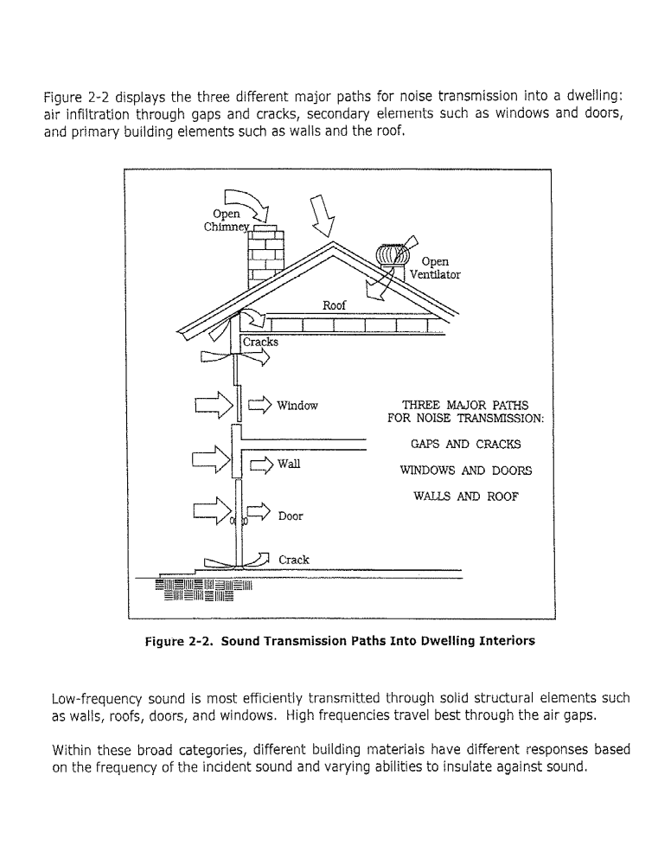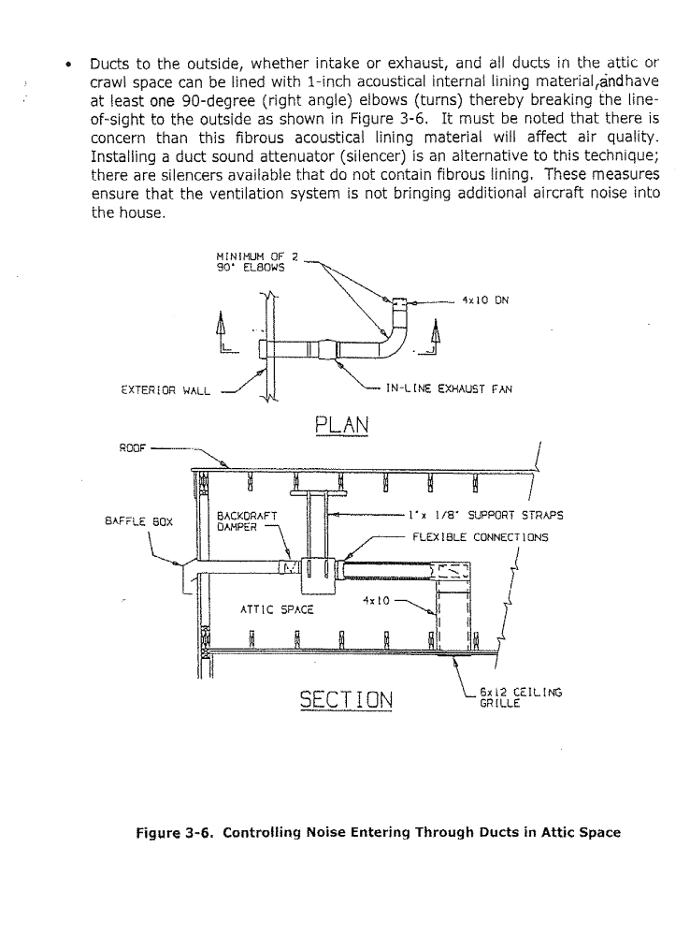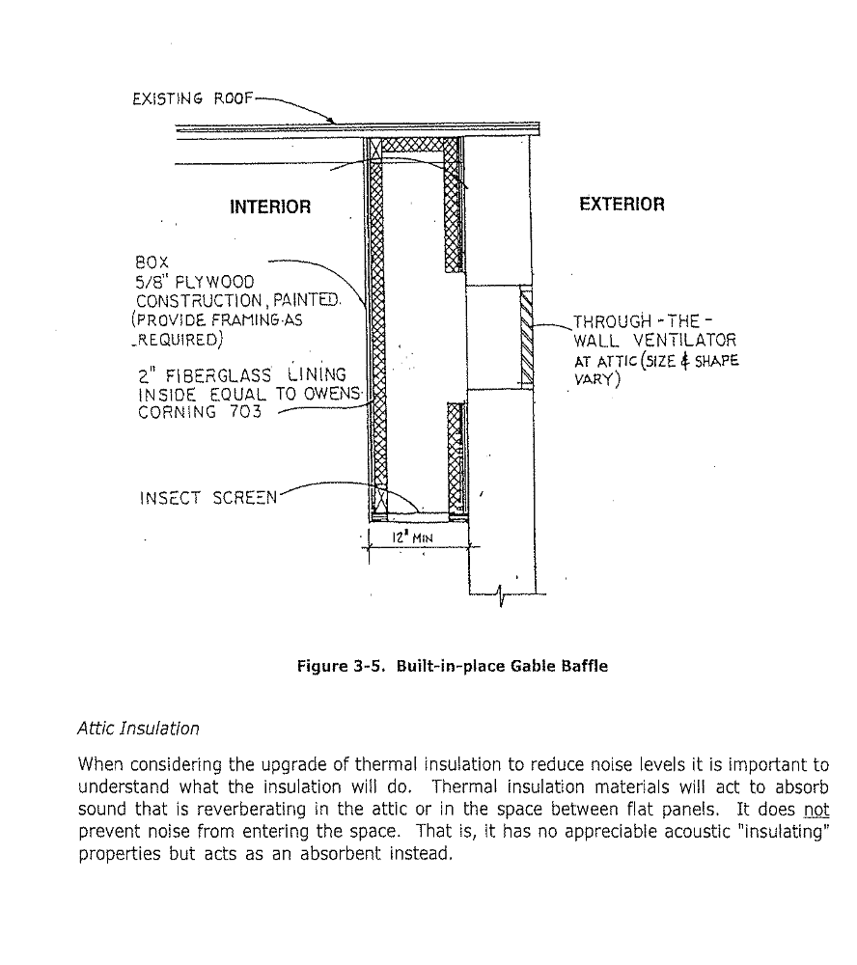
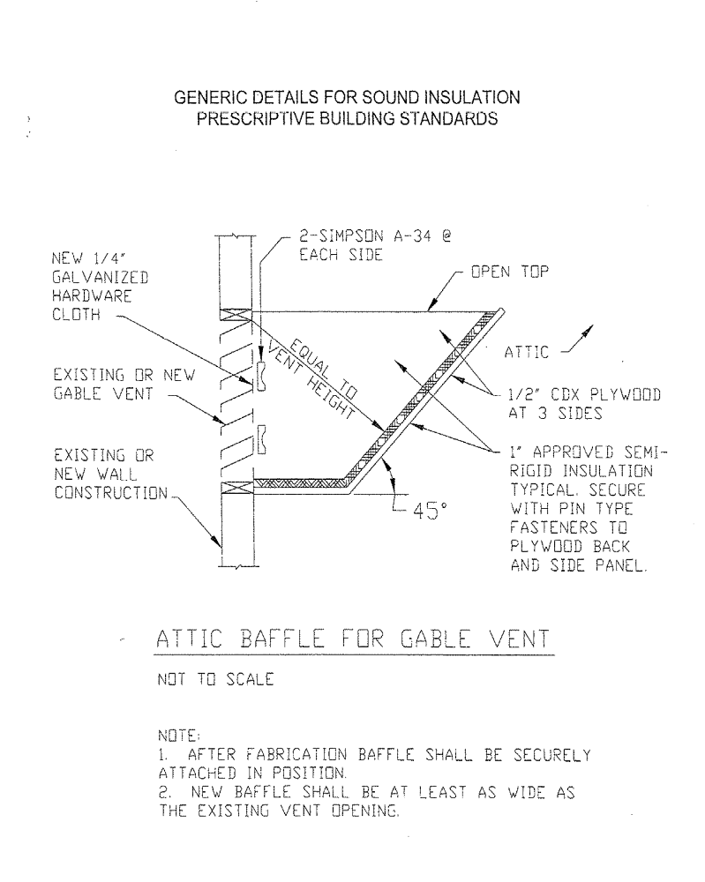

Roof vents

When using roof vents, whether a ridge vent or a single vent, a trough should be constructed and hung from the joists. The trough should be as wide as possible to cover the area of the vent. For ridge vents, it is preferable that it extend from joists to joists, leaving enough room around the edges for the required amount of venting. For single vents, the trough should be installed at the appropriate angle to match the roof slope.

The trough should be as long as the roof vent, perhaps a few inches longer, and capped on the ends.

The inside of the trough should be lined with 1” approved semi-rigid sound insulation.

SECTION L1217
COMPLIANCE TABLES

L1217.1 For allowable compliance tables of walls, windows, doors, roof/ceiling and floors, see the Compliance Packet as approved by the Building Official.
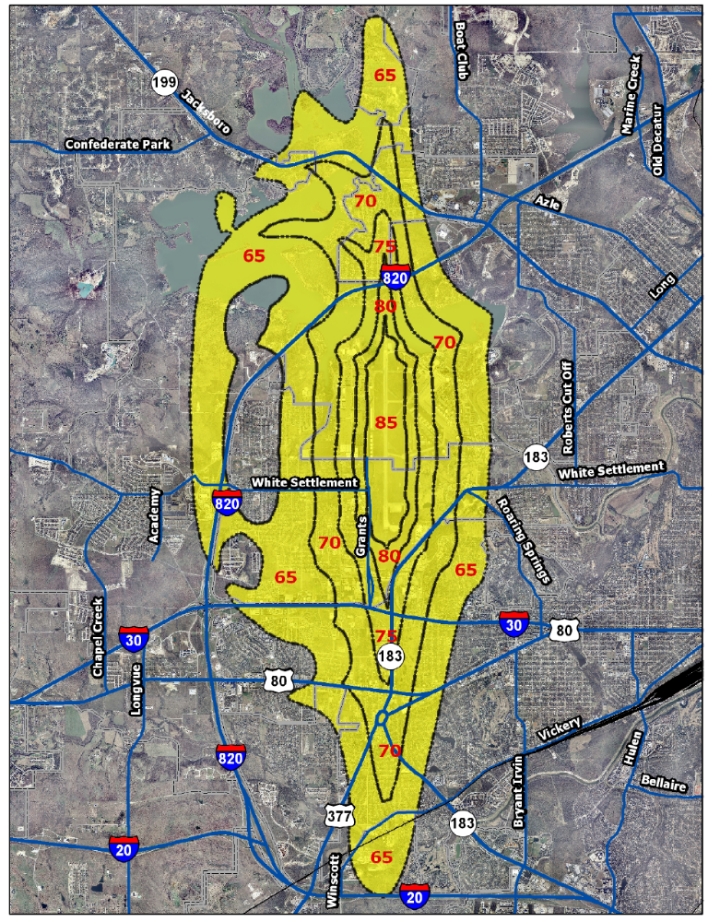

Naval Air Station Joint Reserve Base (NASJRB)
Figure L1212.1(1)
SECTION 3.

Section 7-48 of the Code of the City of Fort Worth (1986) is amended to read as follows:

Sec. 7-48. Effect of conflict with other ordinances.

This article shall be cumulative of all provisions of ordinances of the Code of the City of Fort Worth, Texas (1986), affecting Building Code provisions, as amended, and shall not repeal any of the provisions of such ordinances, except in those instances where provisions of such ordinances are in direct conflict with the provisions of this ordinance.

SECTION 4.

Section 7-49 of the Code of the City of Fort Worth (1986) is amended to read as follows:

Sec. 7-49. Penalty for violation.

Any person, firm, or corporation violating any of the provisions of this ordinance shall be deemed guilty of a misdemeanor and upon conviction thereof shall be punishable by a fine not to exceed Two Thousand Dollars ($2,000.00) for all violations involving fire safety, or public health and sanitation and shall be fined not more than Five Hundred Dollars ($500.00) for all other violations of this ordinance. Each day or any portion thereof during which any violation of this ordinance occurs or continues shall be deemed a separate offense and upon conviction thereof shall be punishable as herein provided.

SECTION 5.

Section 7-226 of the Code of the City of Fort Worth (1986) is amended to read as follows:

Sec. 7-226. Business registration.

Every firm, business or organization consisting of moving and demolition contractors required to be licensed under the provisions of this Code, shall register with the city’s Planning and Development Department. The fee for such business registration shall be as specified in the building code of the city.

SECTION 6.

Section 20-358 of the Code of the City of Fort Worth (1986) is amended to read as follows:

Sec. 20-358. Permit fees.

Application for a sidewalk café permit shall be made in accordance with the provisions specified by the director who shall issue a permit upon compliance with the terms and conditions of this article. The permit fee shall be as specified in the building code and such permit shall be valid for one (1) year from date of issuance.

SECTION 7.

This article shall be cumulative of all provisions of ordinances of the Code of the City of Fort Worth, Texas (1986), affecting Building Code provisions, as amended, and shall not repeal any of the provisions of such ordinances, except in those instances where provisions of such ordinances are in direct conflict with the provisions of this ordinance.

SECTION 8.

It is hereby declared to be the intention of the City Council that the sections, paragraphs, sentences, clauses, and phrases of this ordinance are severable, and, if any phrase, clause, sentence, paragraph, or section of this ordinance shall be declared void, ineffective, or unconstitutional by the valid judgment or decree of any court of competent jurisdiction, such voidness, ineffectiveness, or unconstitutionality shall not affect any of the remaining phrases, clauses, sentences, paragraphs, and sections of this ordinance, since the same would have been enacted by the City Council without the incorporation in this ordinance of any such void, ineffective, or unconstitutional phrase, clause, sentence, paragraph, or section.

SECTION 9.

Any person, firm, or corporation violating any of the provisions of this ordinance shall be deemed guilty of a misdemeanor and upon conviction thereof shall be punishable by a fine not to exceed Two Thousand Dollars ($2,000.00) for all violations involving fire safety, or public health and sanitation and shall be fined not more than Five Hundred Dollars ($500.00) for all other violations of this ordinance. Each day or any portion thereof during which any violation of this ordinance occurs or continues shall be deemed a separate offense and upon conviction thereof shall be punishable as herein provided.

SECTION 10.

All rights and remedies of the City of Fort Worth, Texas are expressly saved as to any and all violations of the previous Building Code, or any other ordinances affecting construction and fire safety, which have accrued at the time of the effective date of this ordinance: and, as to such accrued violations and all pending litigation, both civil and criminal, whether pending in court or not, under such ordinances, same shall not be affected by this ordinance but may be prosecuted until final disposition by the courts.

SECTION 11.

A copy of the 2009 International Building Code, together with the local amendments contained in this ordinance, shall be filed in the office of the City Secretary for permanent record and inspection.

SECTION 12.

The Department of Planning and Development of the City of Fort Worth, Texas, is hereby authorized to publish this ordinance in pamphlet form for general distribution among the public, and the operative provisions of this ordinance as so published shall be admissible in evidence in all courts without further proof than the production thereof, as provided in Chapter XXV, Section 3, of the Charter of the City of Fort Worth, Texas.

SECTION 13.

The City Secretary of the City of Fort Worth, is hereby directed to publish the caption and Sections 1, 9, 11, 13 and 14 of this ordinance for two (2) days in the official newspaper of the City of Fort Worth, Texas as authorized by Section 2, Chapter XXV of the Charter of the City of Fort Worth, Texas and by Section 52.013 (a) of the Texas Local Government Code.

SECTION 12.

This ordinance shall take effect upon January 1, 2017, except Section 423.4 shall take effect on April 1, 2017.

APPROVED AS TO FORM AND LEGALITY:

By: ________________________________
Assistant City Attorney

Adopted: ______________

Effective: ______________

1-5-11

